

**Unit:**

**Dynamic Websites**

**Assignment title:**

**Woodland Away, DEC 2017**

**Important notes**

* Please refer to the *Assignment Presentation Requirements* for advice on how to set out your assignment. These can be found on the NCC Education website. Click on ‘Policies & Advic ‘Student Support’.
* You must read the NCC Education documents *What is Academic* *Misconduct? Guidance for Candidates* and *Avoiding Plagiarism and Collusion: Guidance for Candidates* and ensure that you acknowledge all thesources that you use in your work. These documents are available on the

NCC Education website. Click menuon and‘Po then click on ‘Student Support’.

* You **must** complete the *Statement and Confirmation of Own Work*. The form

is available on the NCC Education website. Click on ‘Polic the main menu and then click on ‘St

* Please make a note of the recommended word count. You could lose marks if you write 10% more or less than this.
* You must submit a paper copy and digital copy (on disk or similarly acceptable medium). Media containing viruses, or media that cannot be run directly, will result in a fail grade being awarded for this assessment.
* All electronic media will be checked for plagiarism.





Student Declaration

I have read and understood NCC Education’s Policy on Academic Dishonesty and Plagiarism.

I can confirm the following details:

|  |  |  |
| --- | --- | --- |
| Student ID/Registration number: | 00159128 | |
| Name: | Md. Jhadul Islam Rakib | |
| Centre Name: | Daffodil International Academy | |
| Module Name: | Dynamic websites | |
| Module Leader: | | Kazi Sanghati Sowharda Haque |
| Number of words: |  | |
| I confirm that this is my own work and that I have not plagiarized any part of it. I have also noted the assessment criteria and pass mark for assignments. | | |
| Due Date: | 16/10/2017 | |
| Student Signature: | Md. Jhadul Islam Rakib | |
| Submitted Date: | 16/10/2017 | |

Contents

Introduction: 4

Task 1: 4

Setup page and tables: 4

Database Tables: 10

Task 2: 11

User Login: 11

Registration Code: 12

View of registration and Login form: 14

Task 3: 17

About Us: 22

All Message: 25

All Places: 27

Task 4: 32

Package View: 33

Calendar and Special Offer: 35

Task 5: 40

Task 6: 43

Task 7: 48

View: 48

Question & Ans: 49

Dashboard: 52

Task 8: 55

News Letter: 55

Task 9: 56

What I learnt: 56

Improved or further development: 56

Most difficult part: 56

Conclusion: 57

References 57

# Introduction:

This assignment will contain nine particular and different tasks. First of all, we have make a setup page, then need to make a registration, login then another task also. Task 8 contain about newsletter. Task 9 will contain a short description about me that how skill is developed, faces of difficulties etc. we working for Woodlands Away website and now I describe the process of working.

# Task 1:

## Setup page and tables:

This file name is index.php which located on main directory of project folder. After run this file it will create a database and insert some value into database for first time opening.

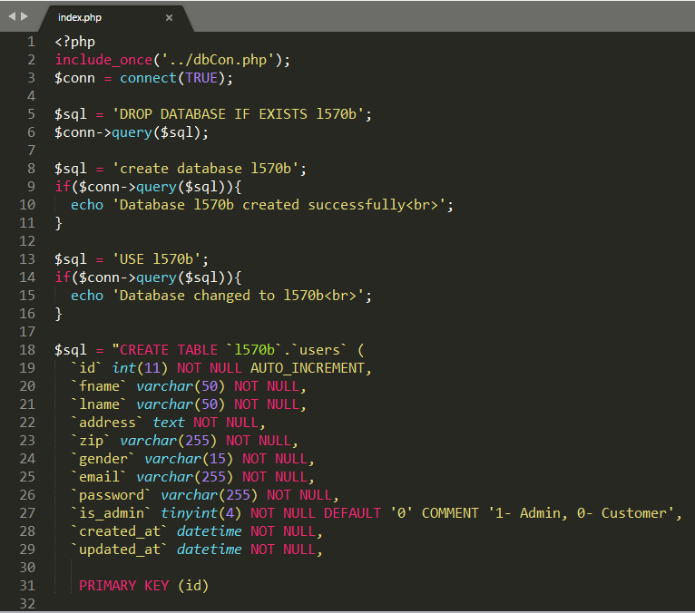

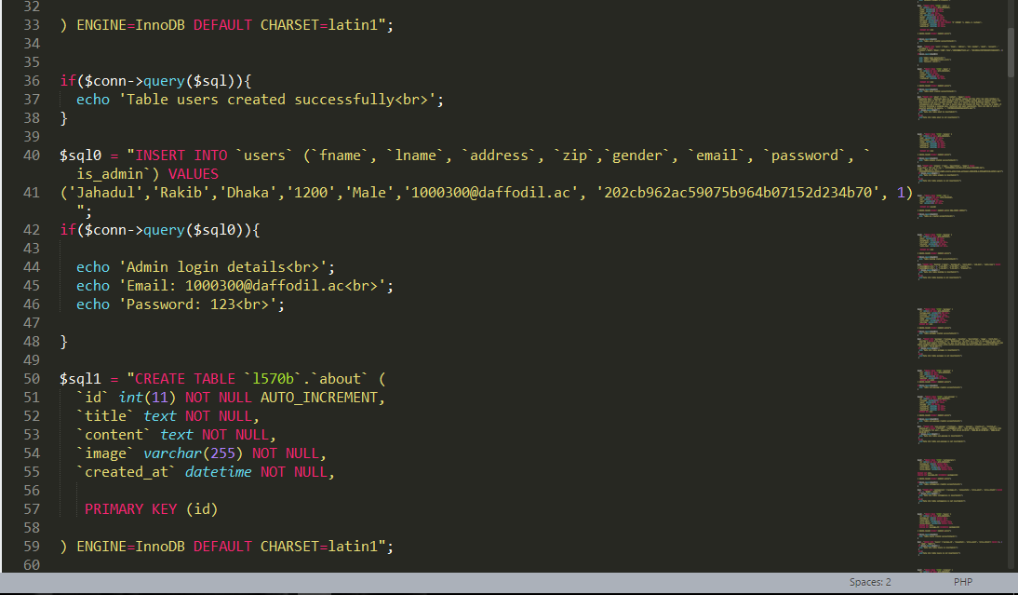

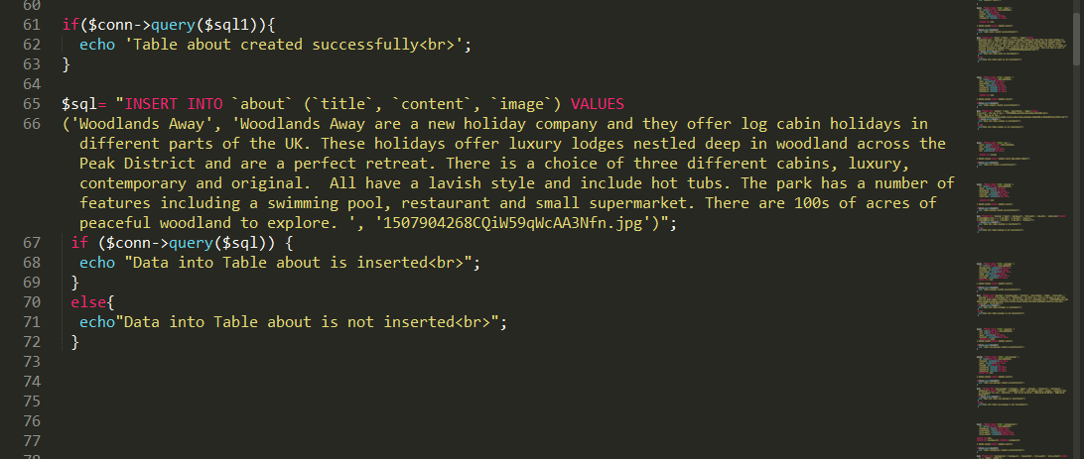

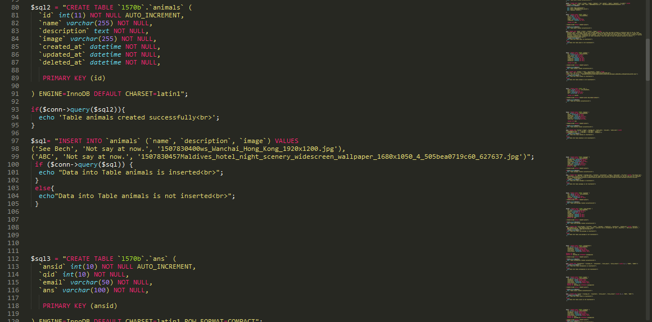

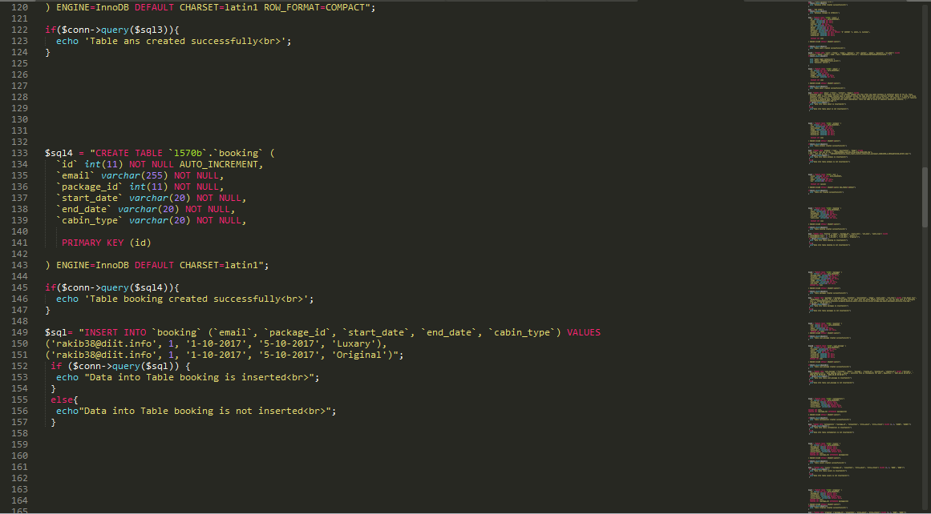

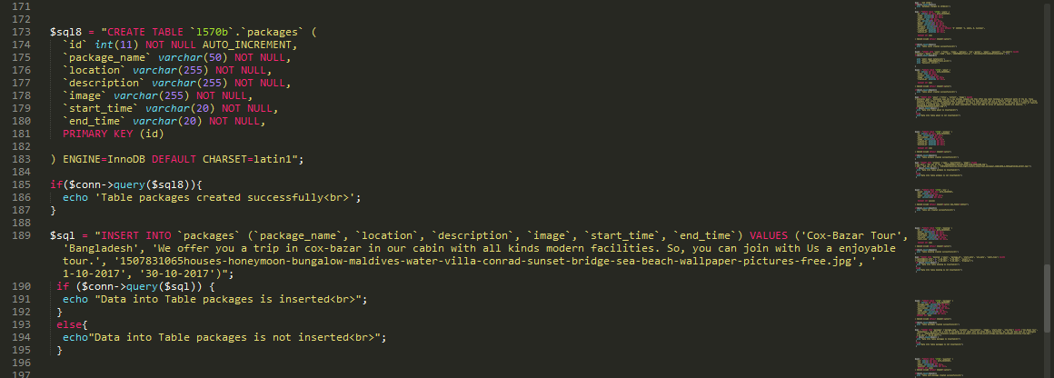

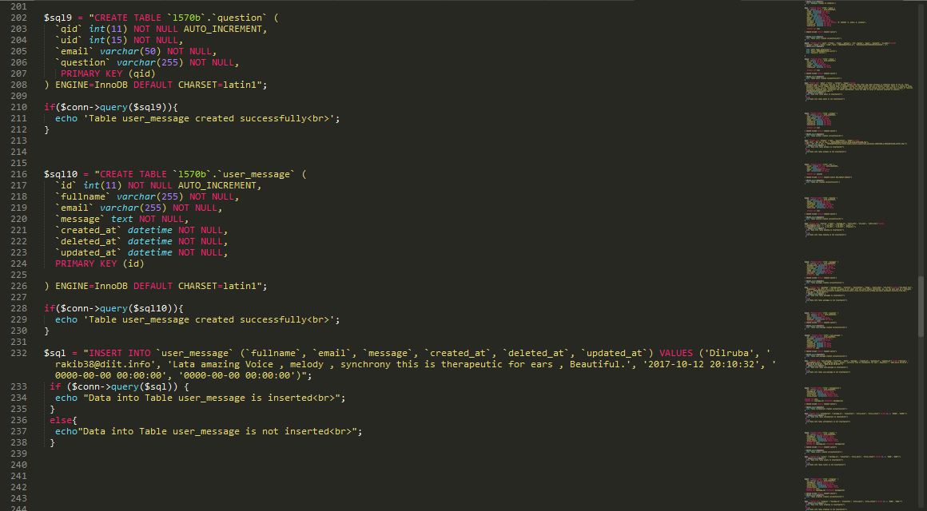

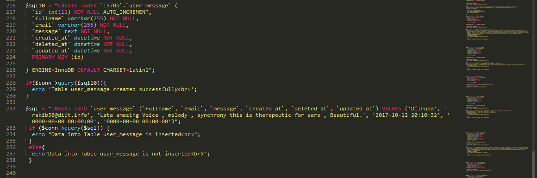

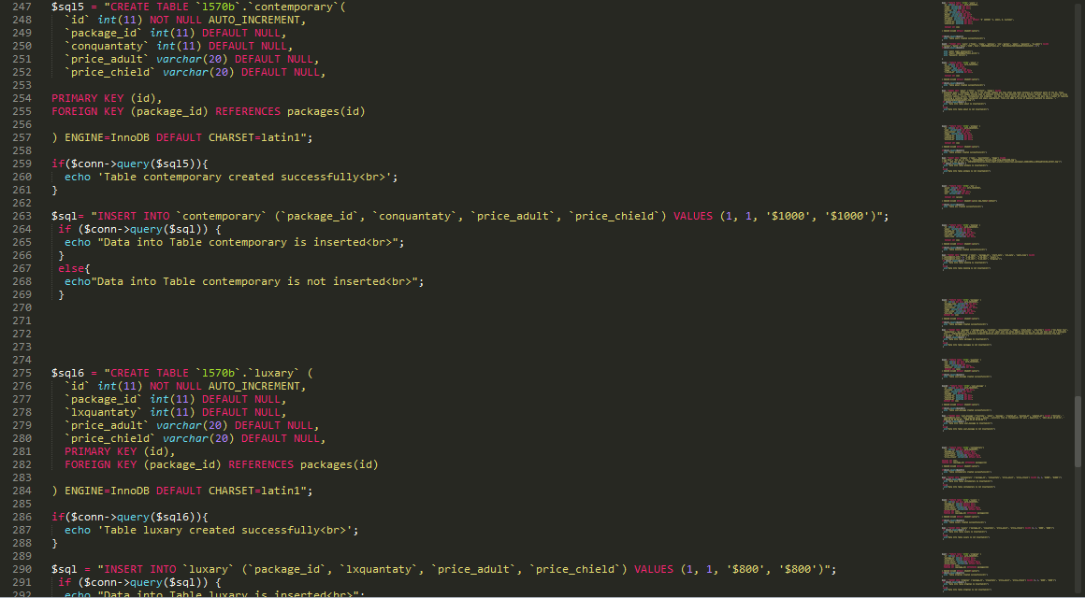

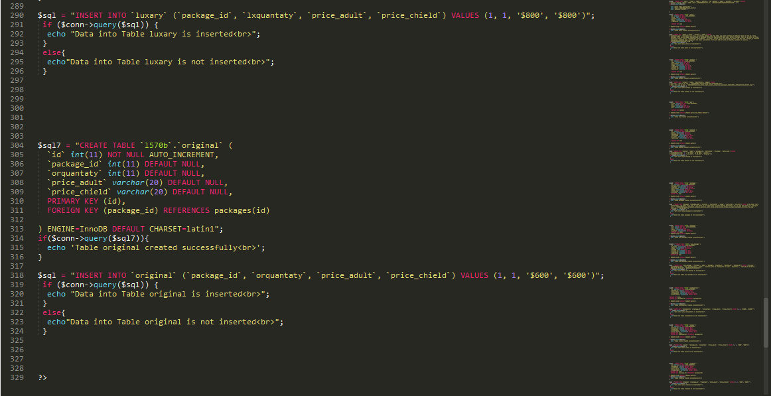

After running this file. It will create a Database which name is l570b and give a message that about the creation of Database.

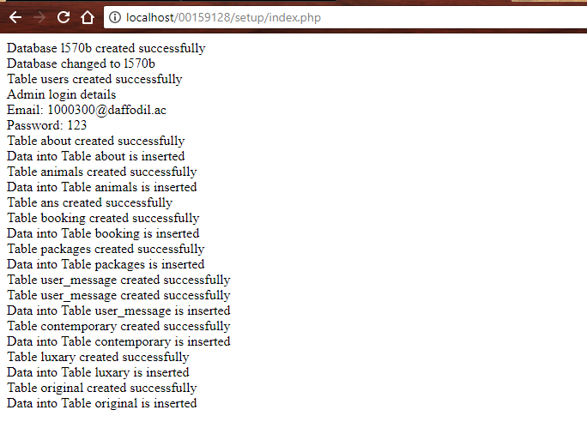

Give a message of Successful.

## Database Tables:

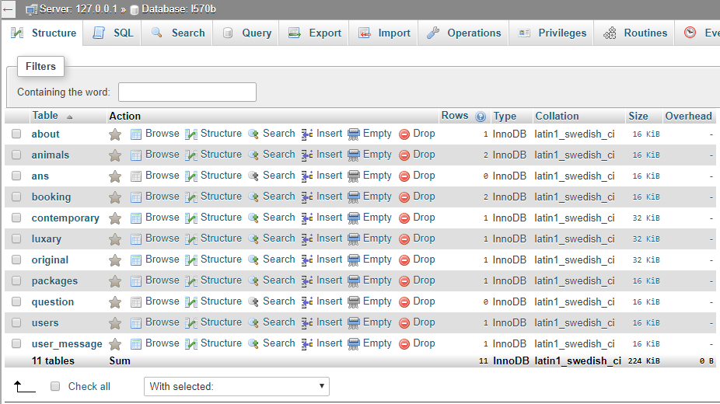

# Task 2:

Now we are going to registration form where we take some personal information from users. It will complete to follow some specific tasks. I will try describe the following process.

* HTML &CSS: Designed for user interface.
* PHP: Inspection error & make connection between database and user interface.
* JAVASCRIPT: Examination the authentication.
* AJAX: Form charging the selected content without full page.
* BOOTSTRAP: Manipulative user interface.

## User Login:

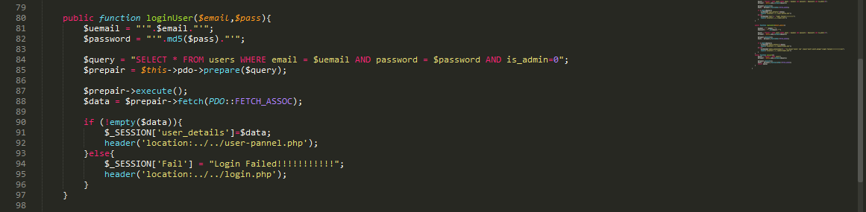Admin Login:

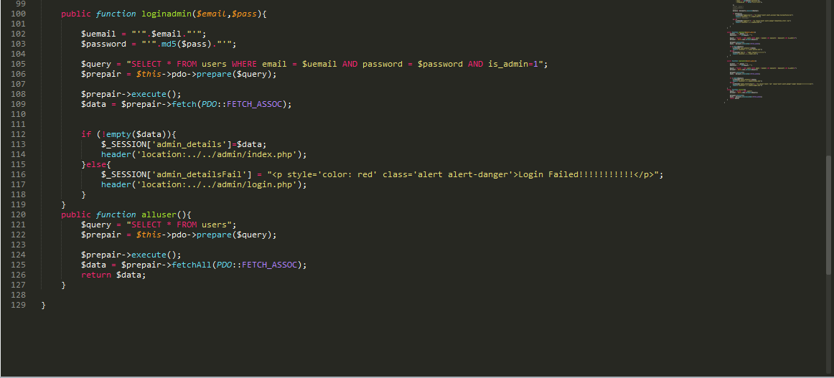

## Registration Code:

I only show here backend code. In this task I use php, jQuery, database etc.

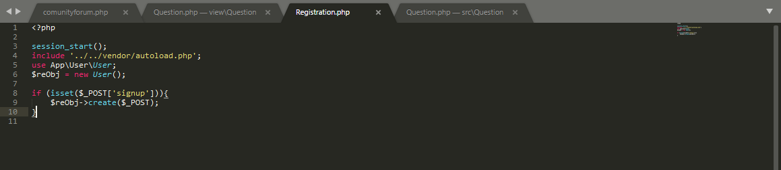

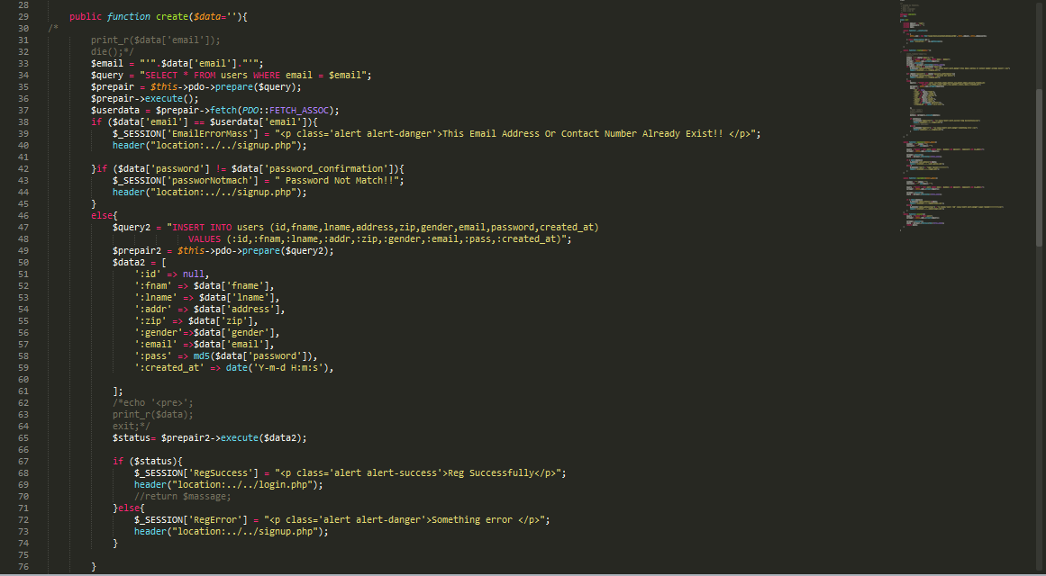

I try some of html code to show here for regstation form. Screen shot is given bellow.

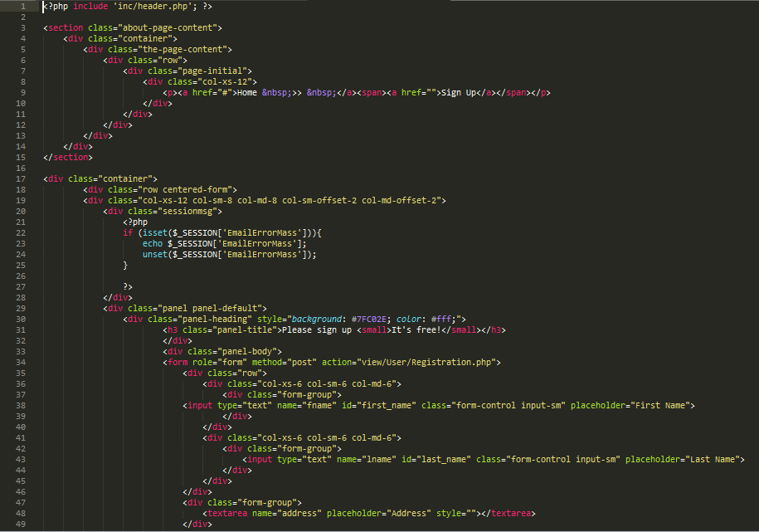

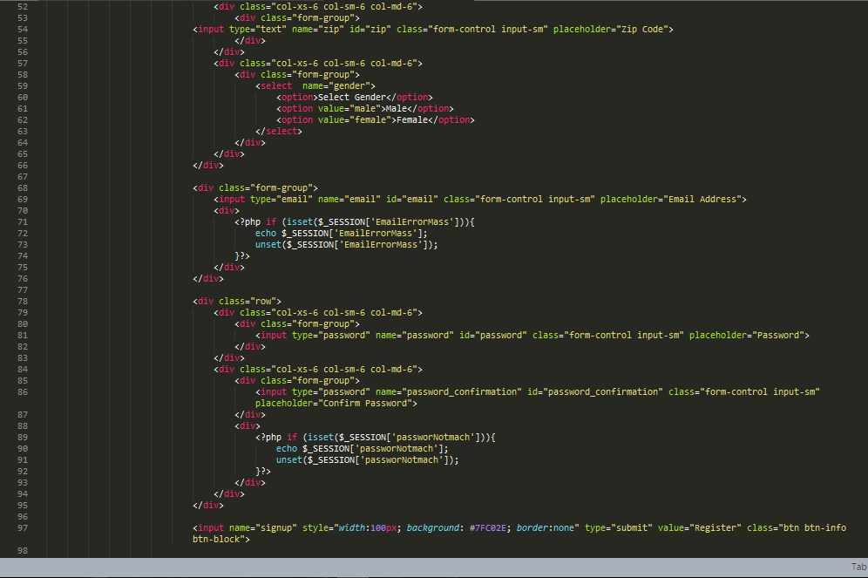

### View of registration and Login form:

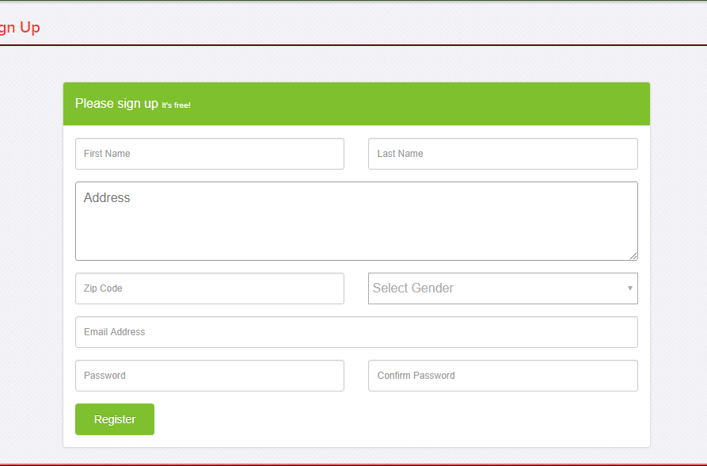

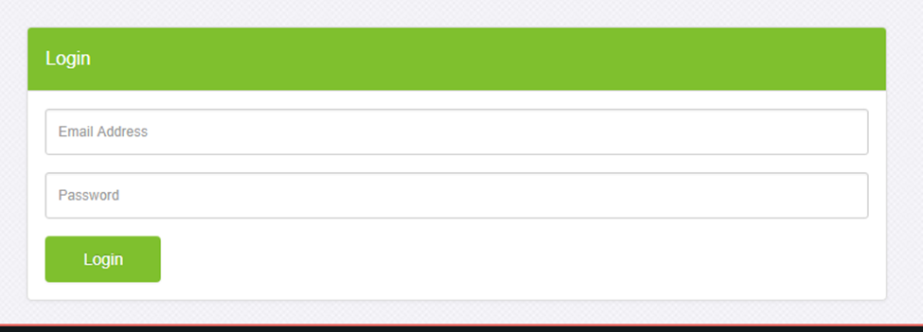

When match any email with already exit in email address.

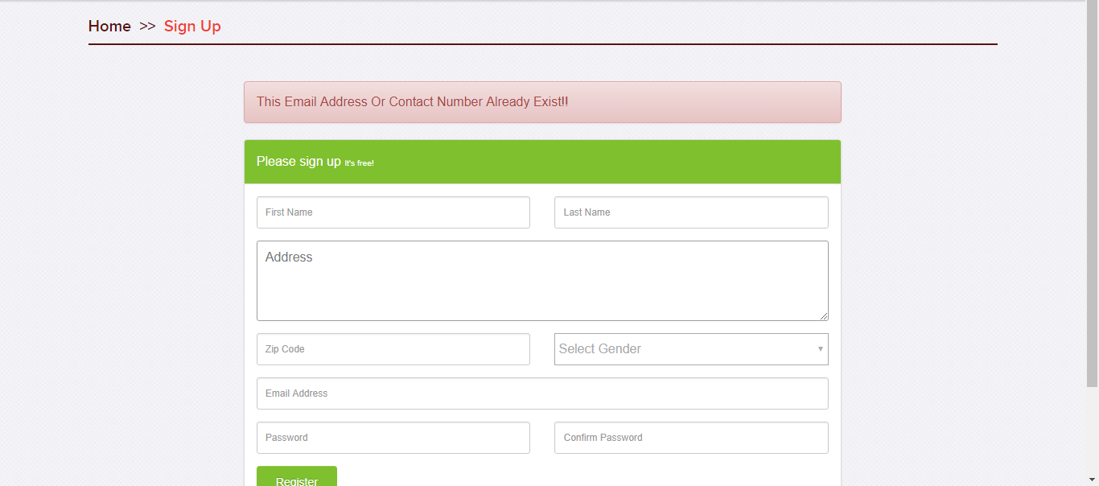

After Successfully Log In

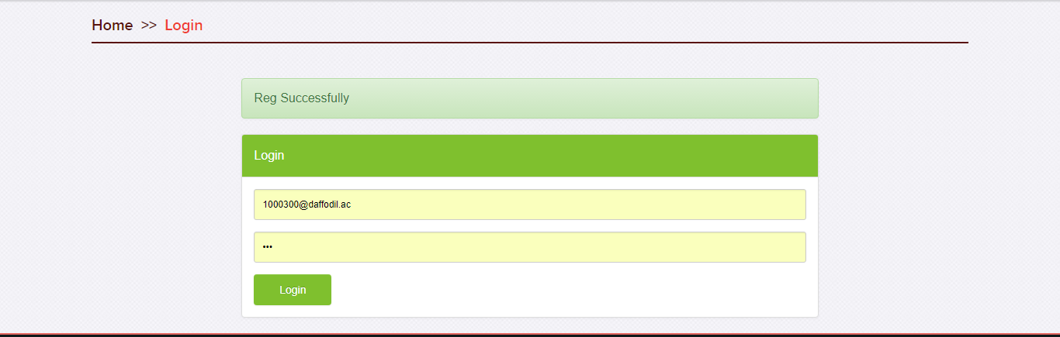

Admin Log in Page:

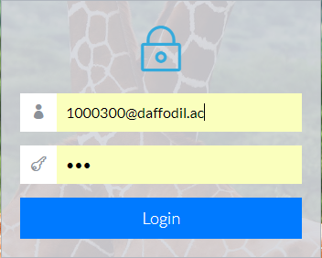

# Task 3:

Add Package with Different price for different cabin in Woodlands Away. Now I describe the following process and gives some screen shot from code. (w3schools, n.d.)

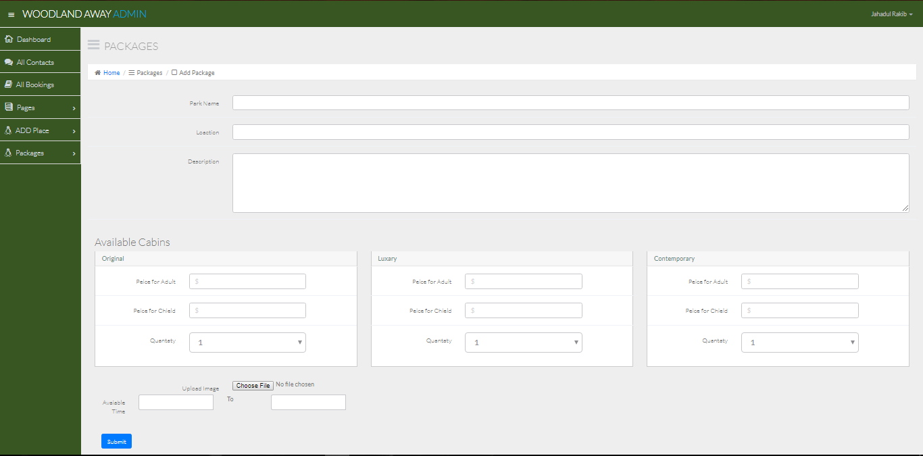

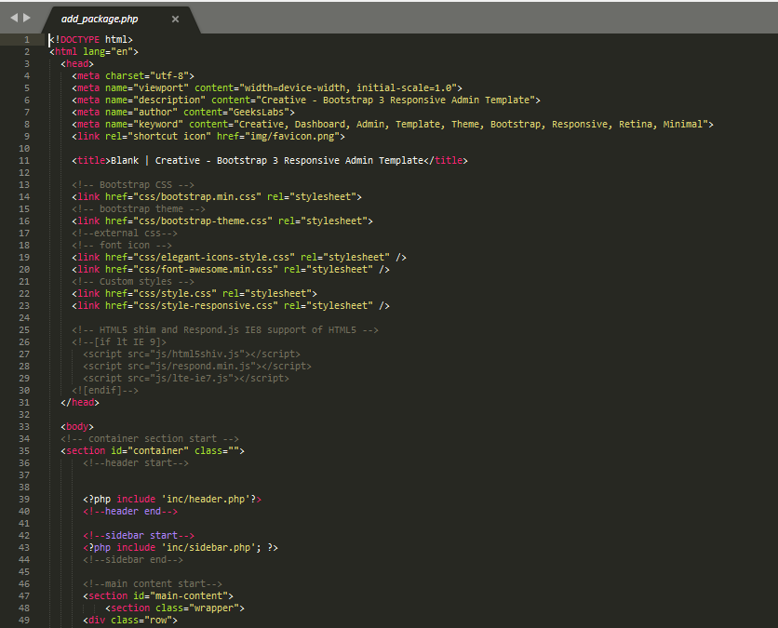

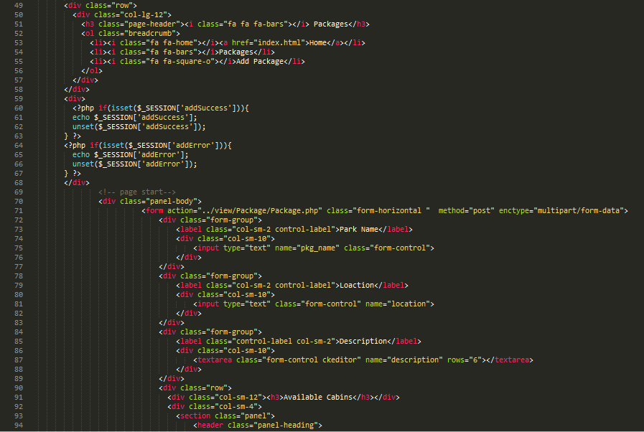

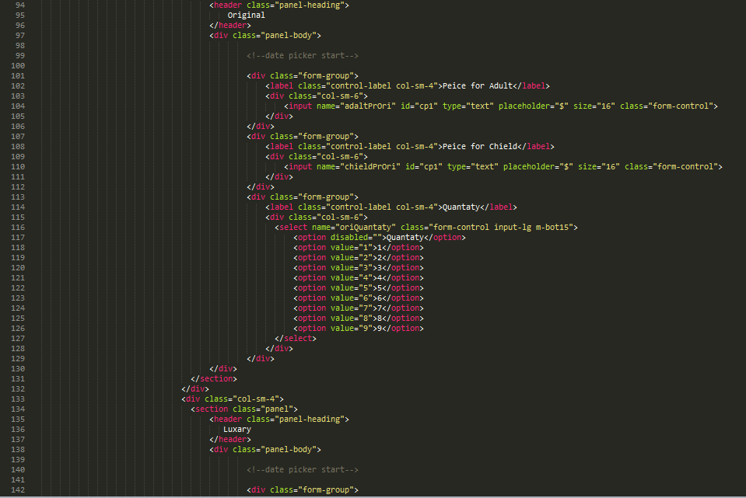

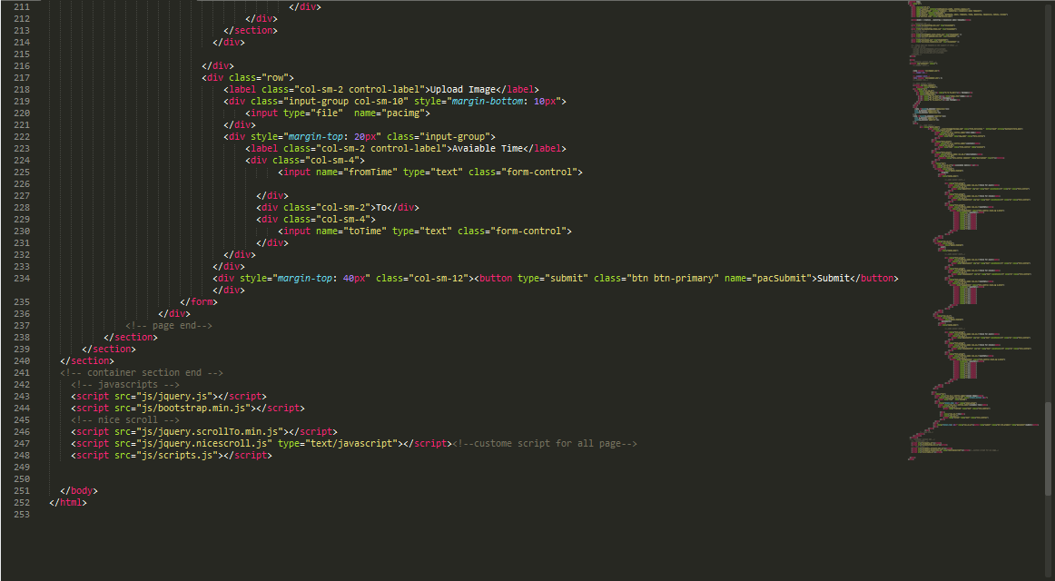

Create Package and Store On database:

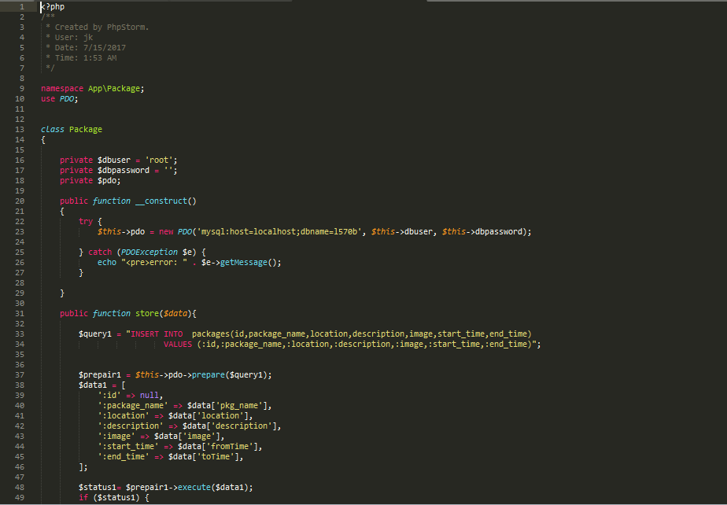

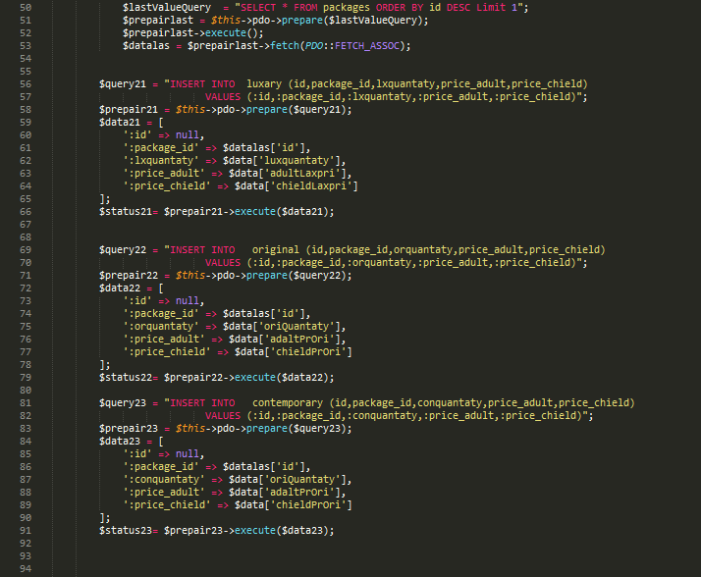

After Create Package It will published For user from database.

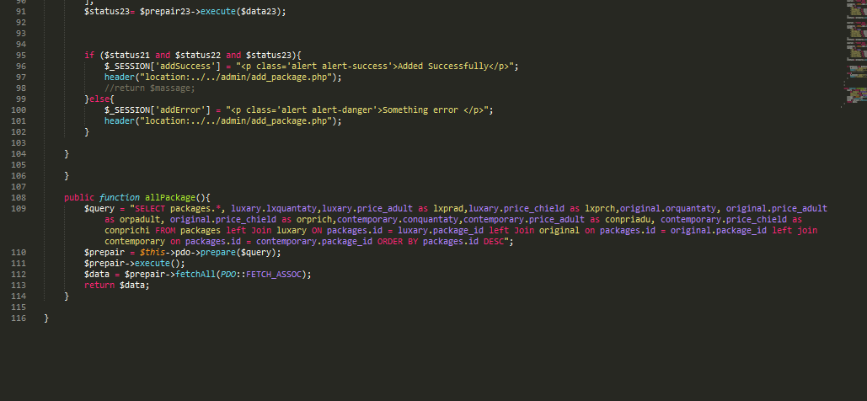

In here I like to put about us option which is dynamically updated from admin. Admin can also see some data from inputted user though it not a term of assignment.

## About Us:

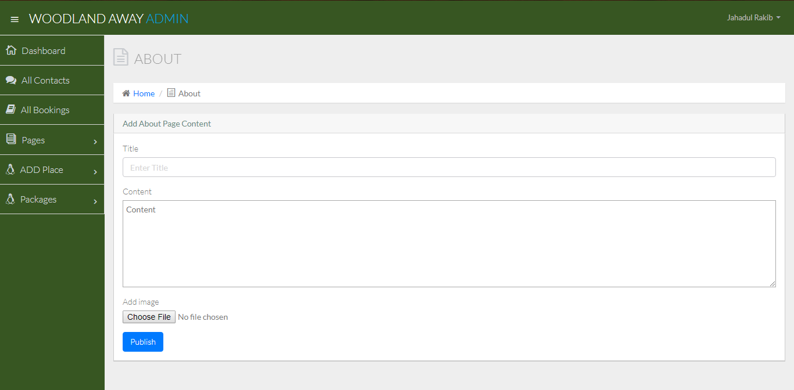

Update About Us Content and Image. Data will added and then published.

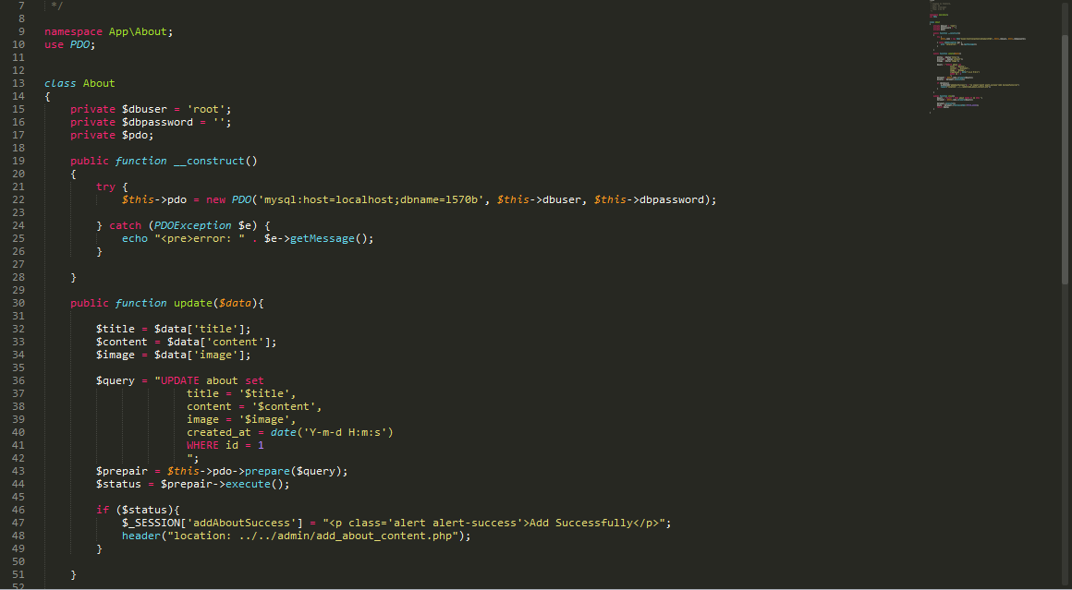

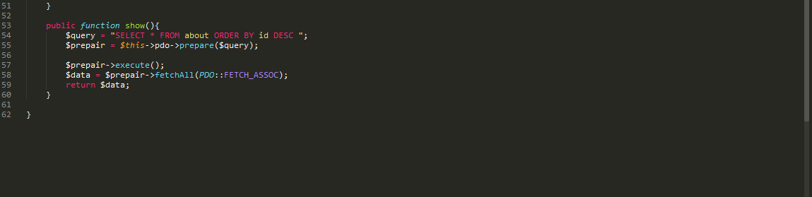

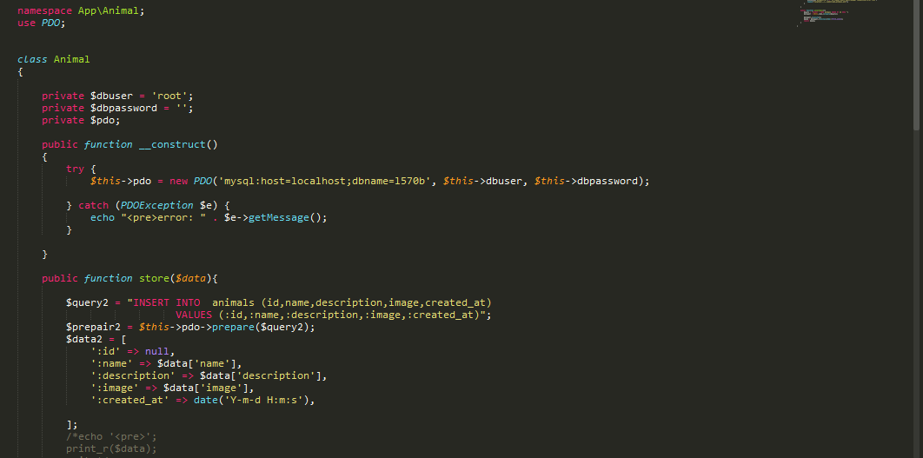

Publishing Function:

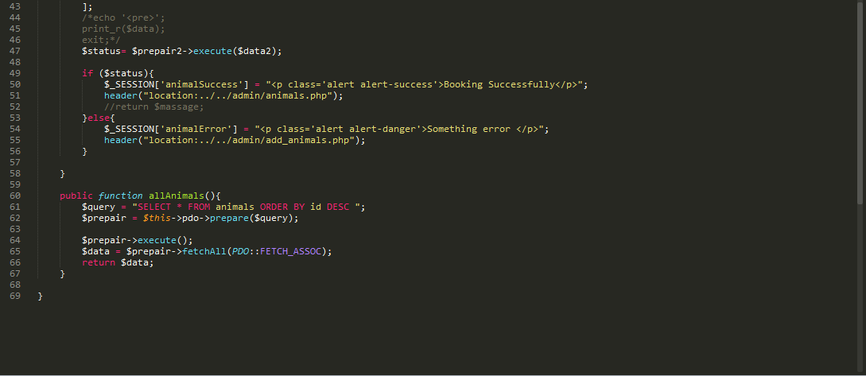

## All Message:

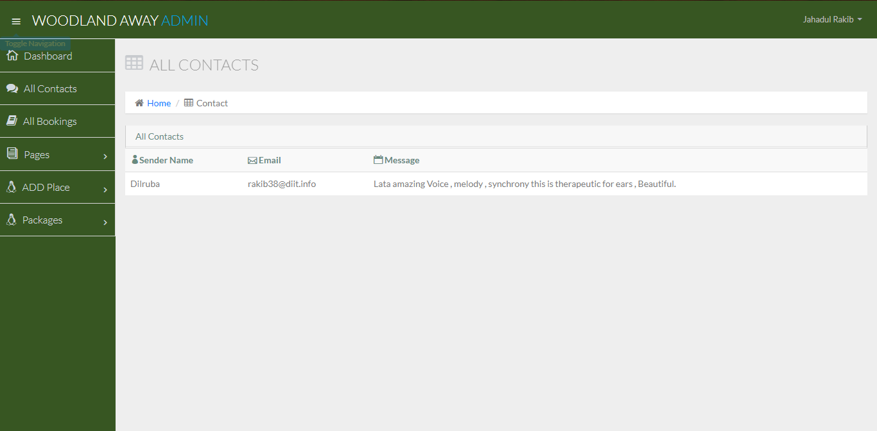

Working code of contact Us Option. In this area used contact to admin.

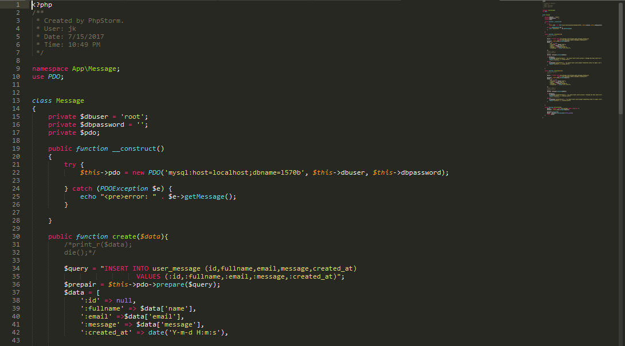

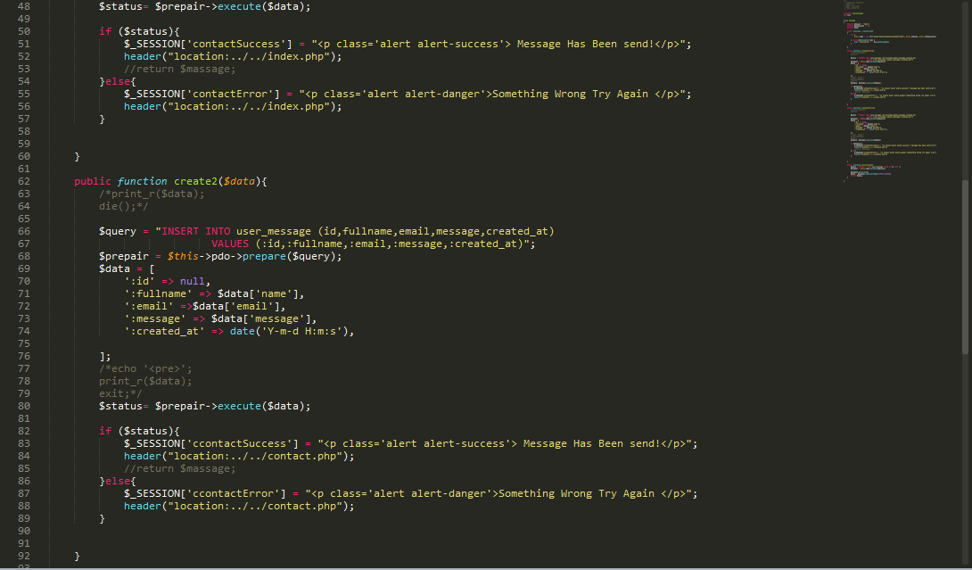

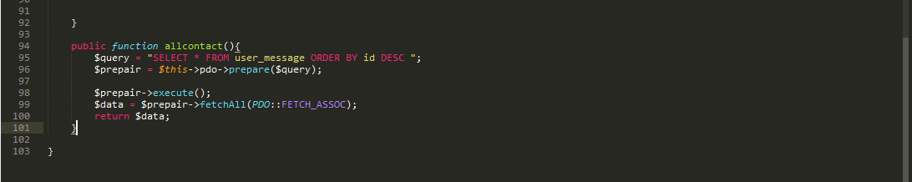

## All Places:

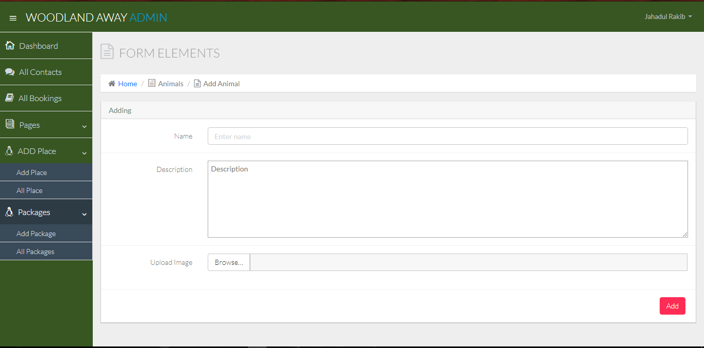

Used for Add Image and Description in this website.

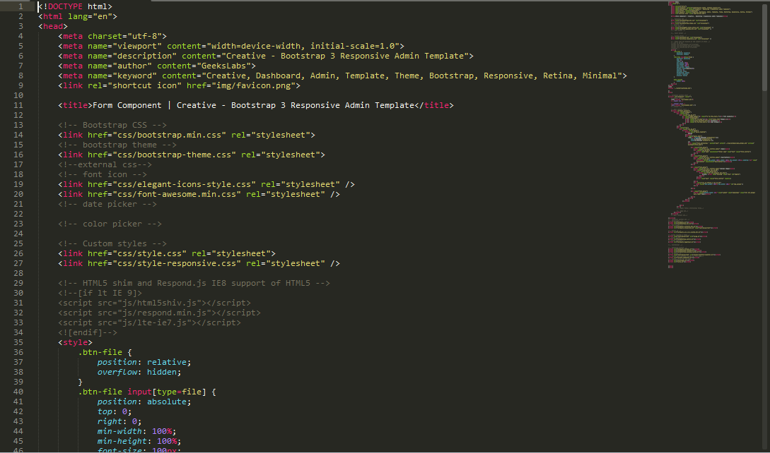

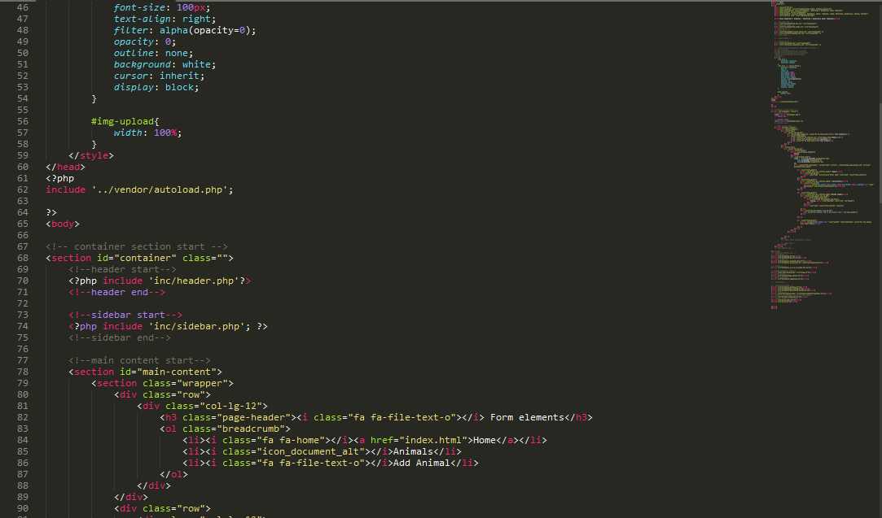

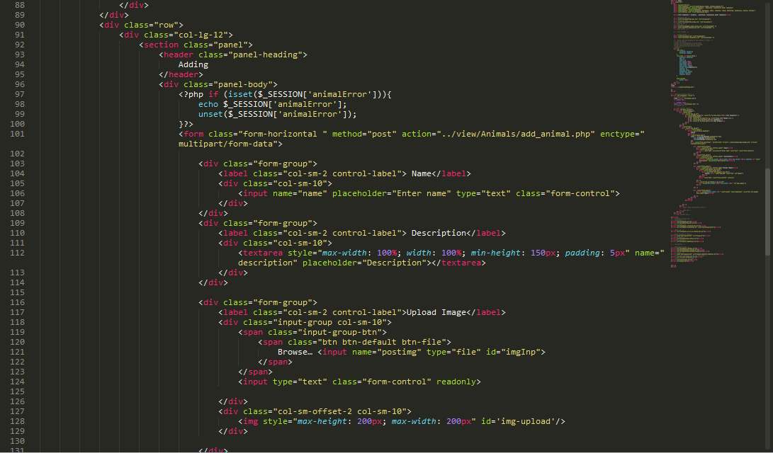

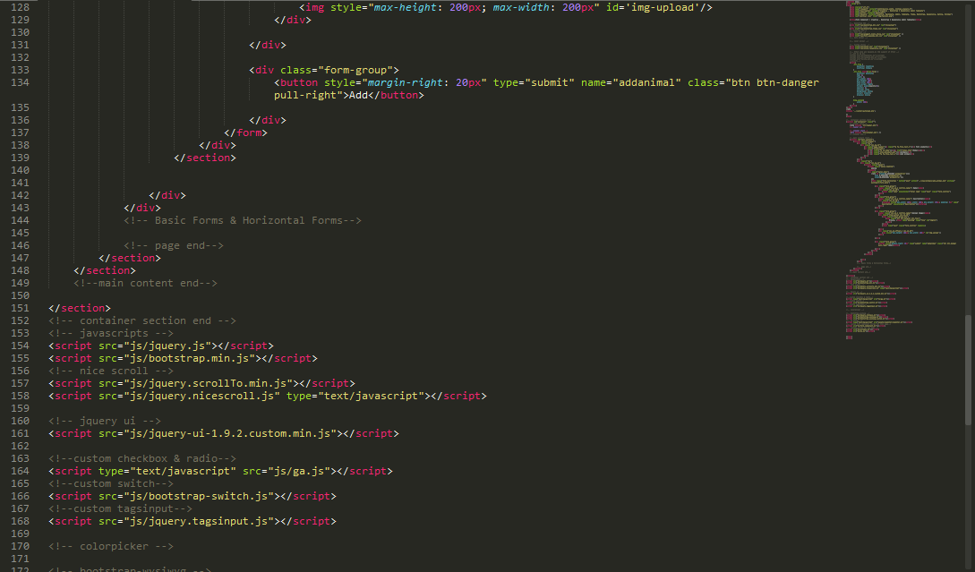

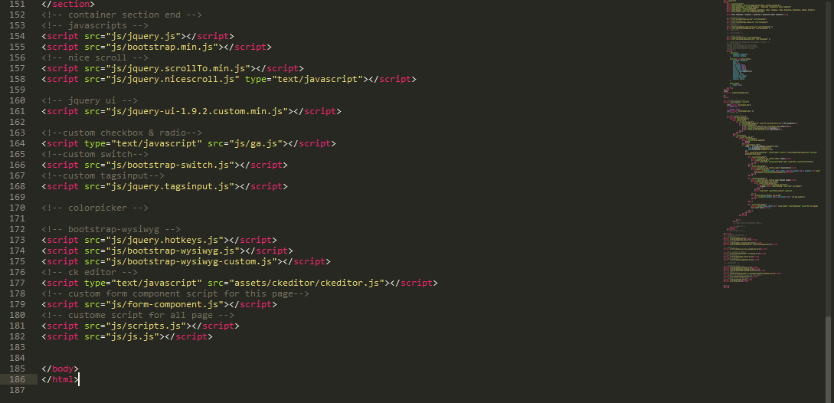

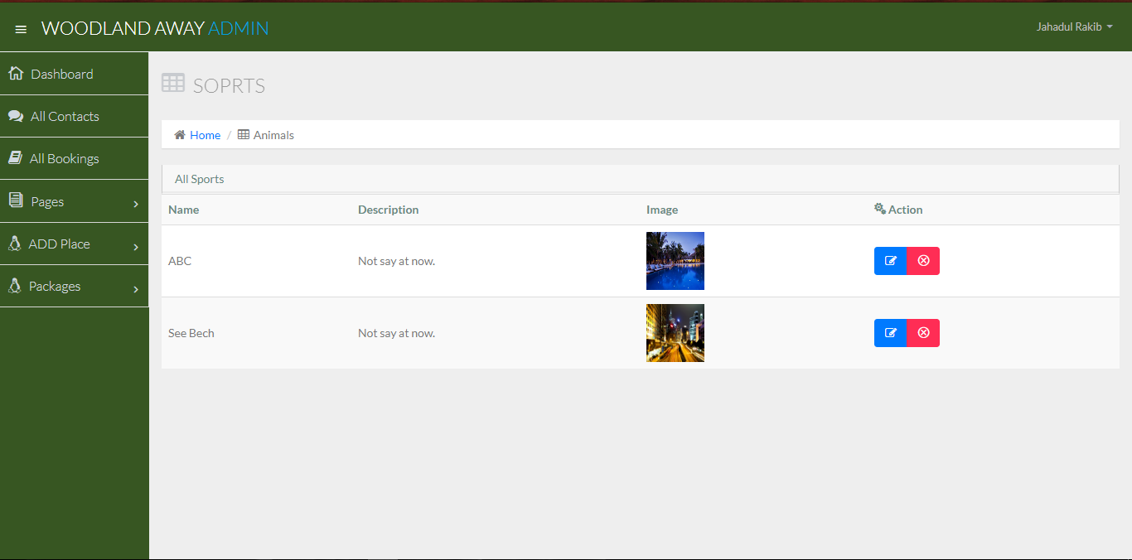

This used for to see all uploaded and description in website.

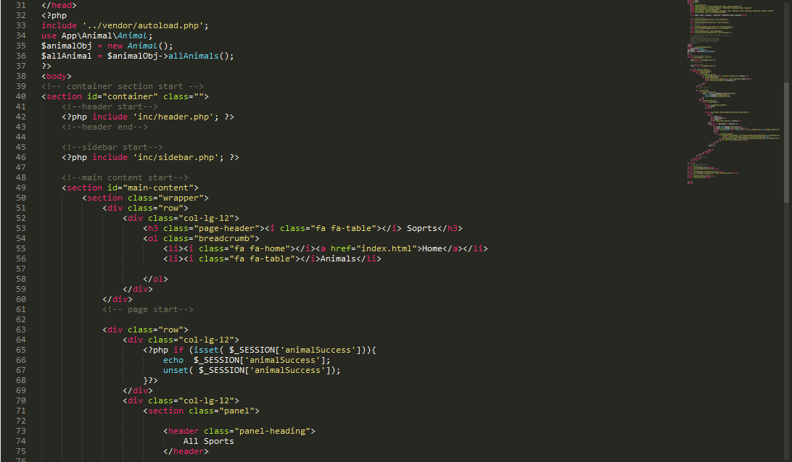

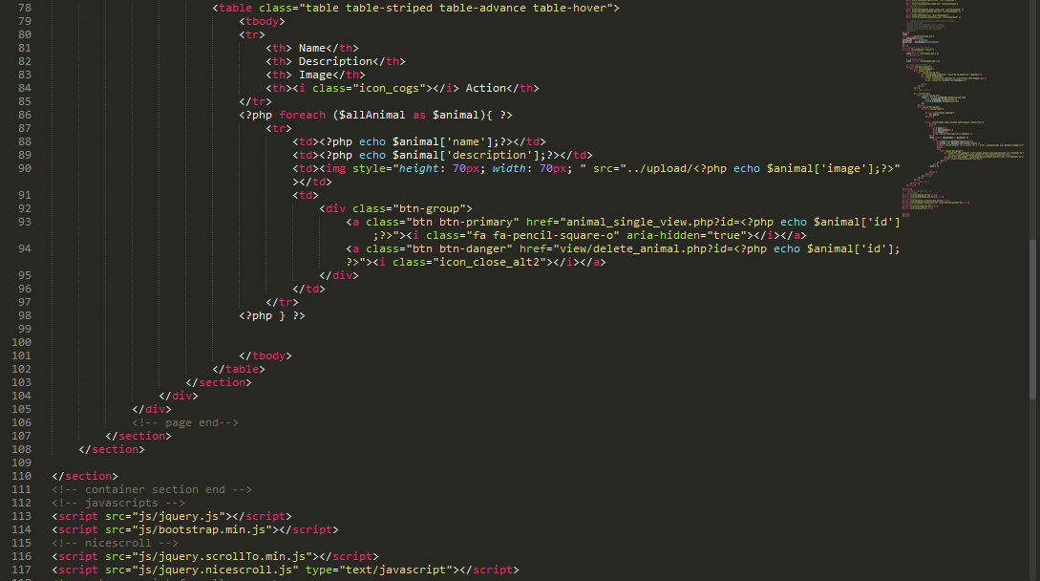

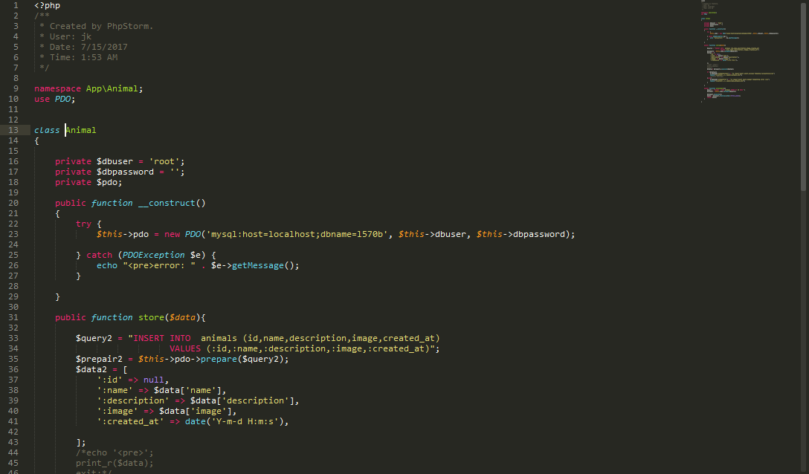

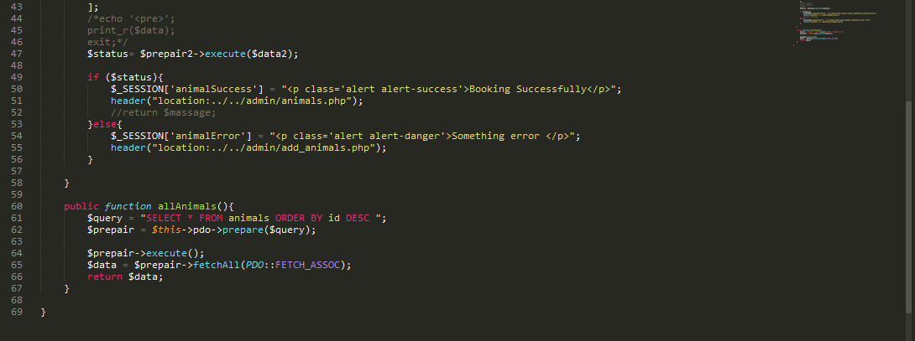

# Task 4:

In here I will try to describe about packages for customers and special offers and prices. Here some screen shots.

## Package View:

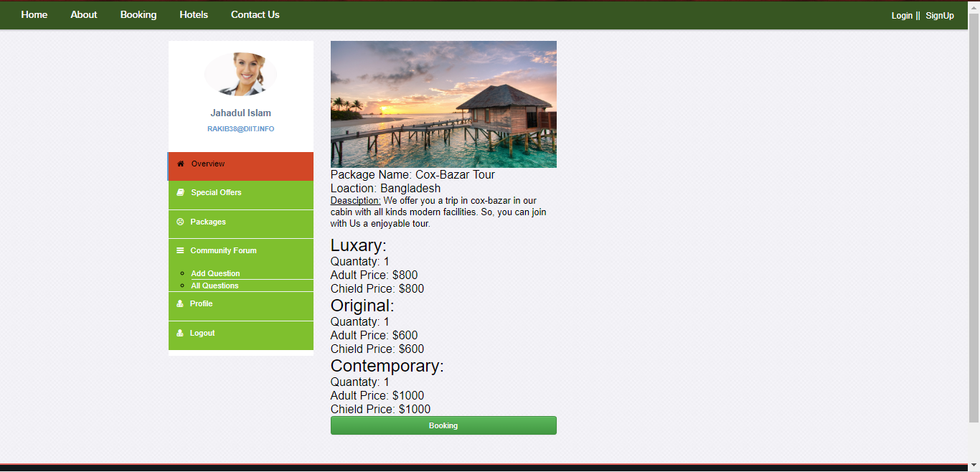

In this field Show all Packages from Database which created by admin.

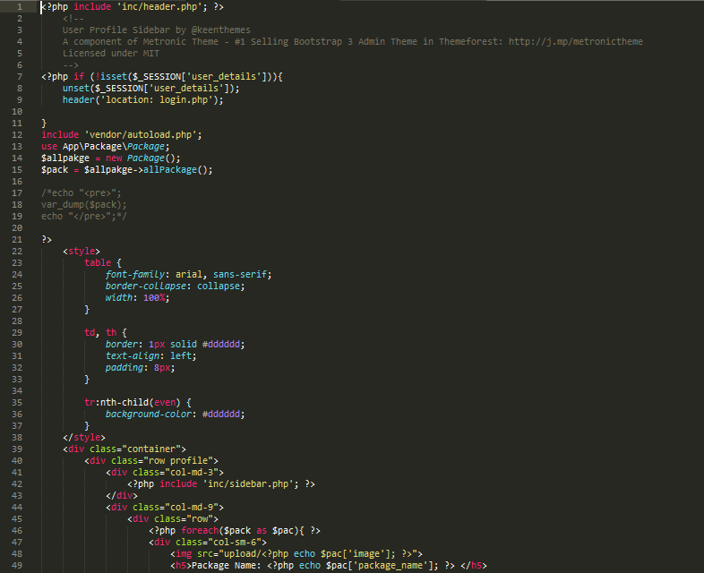

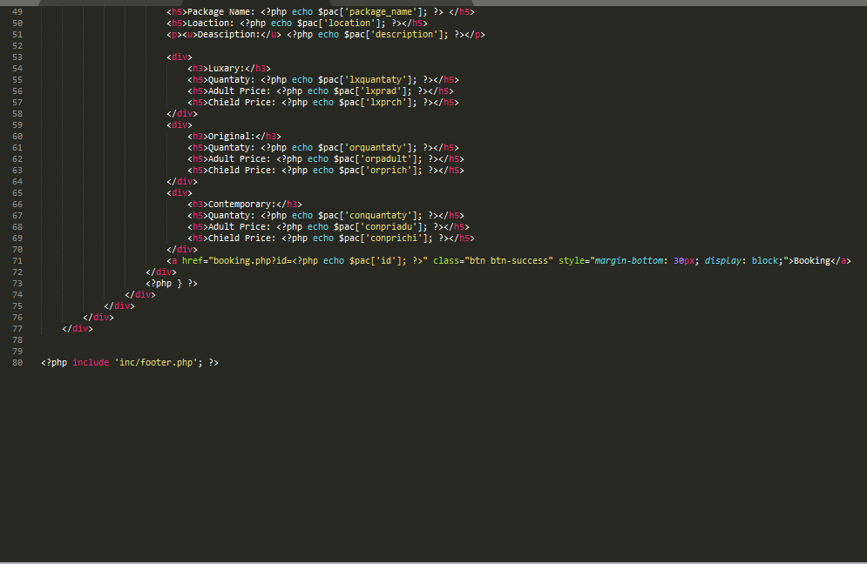

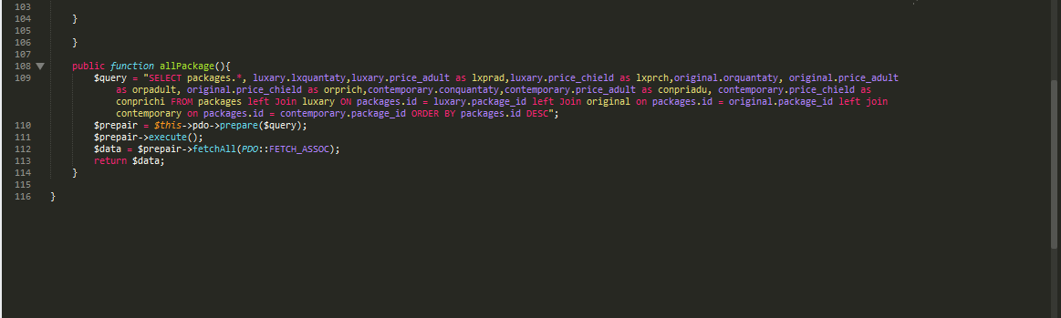

## Calendar and Special Offer:

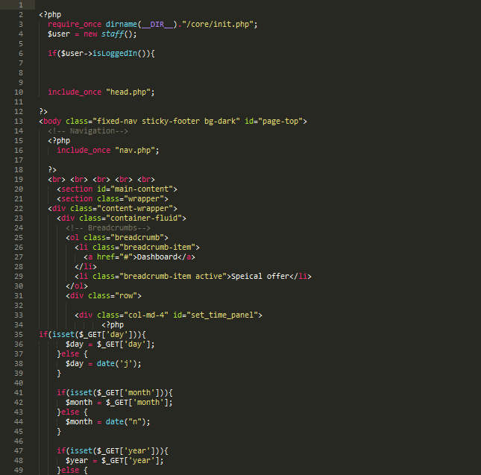

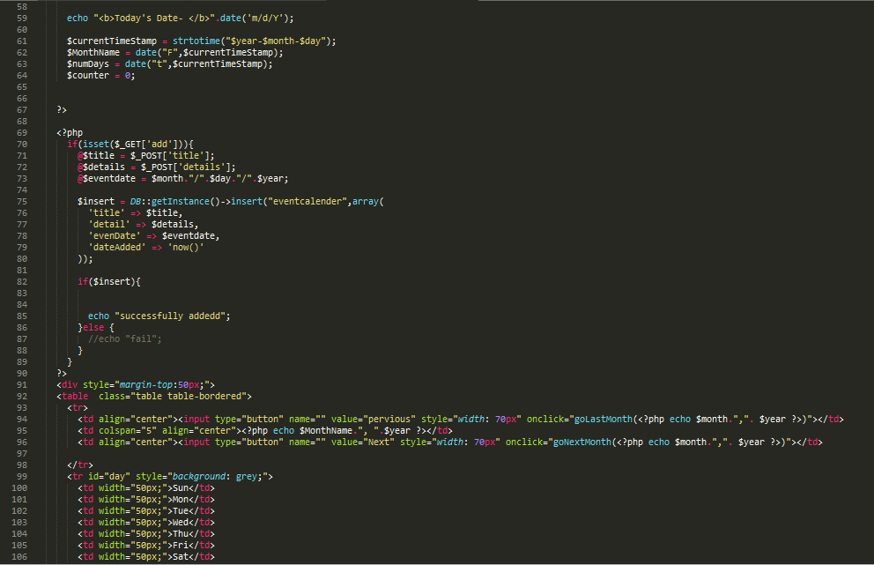

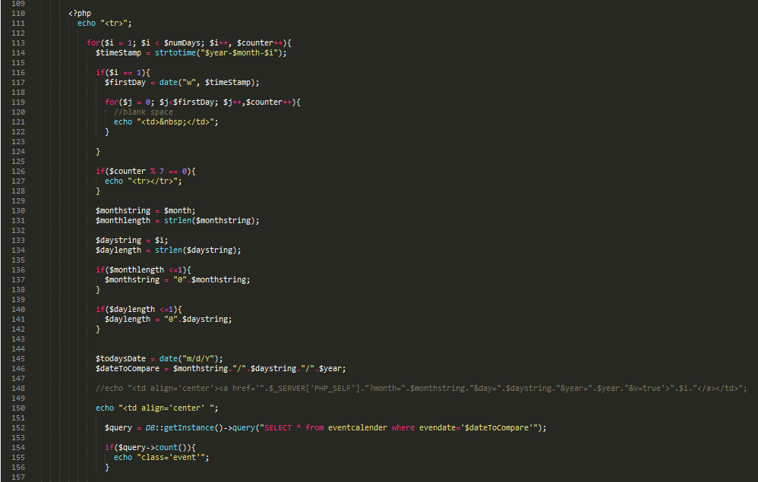

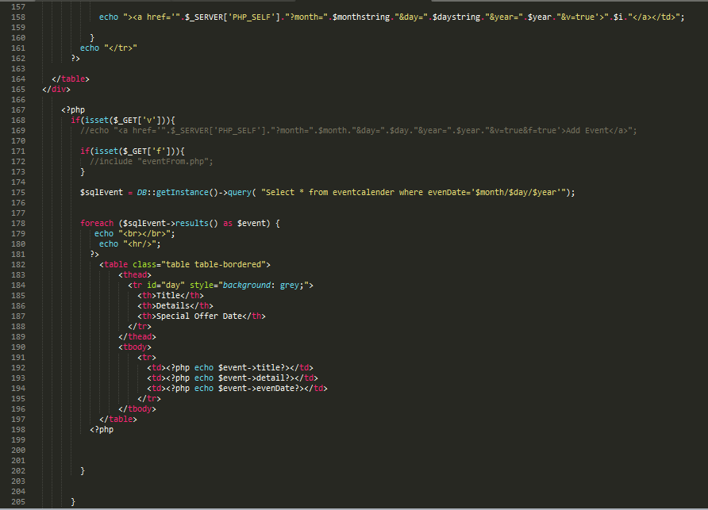

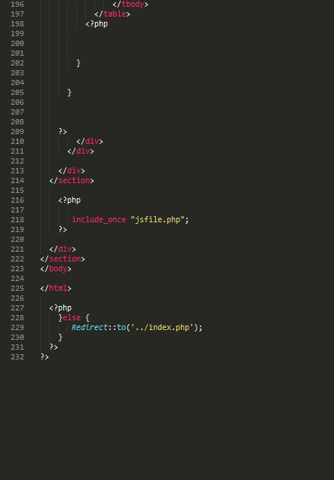

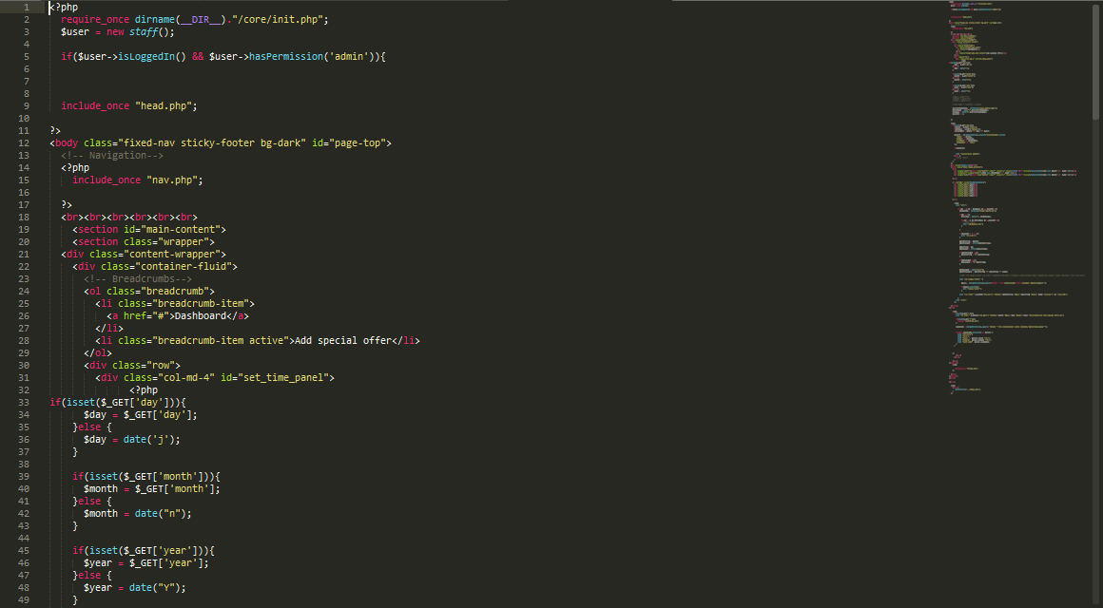

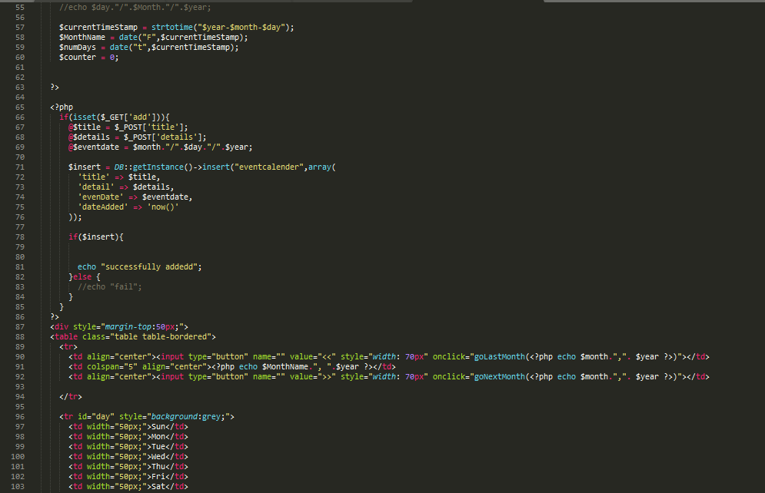

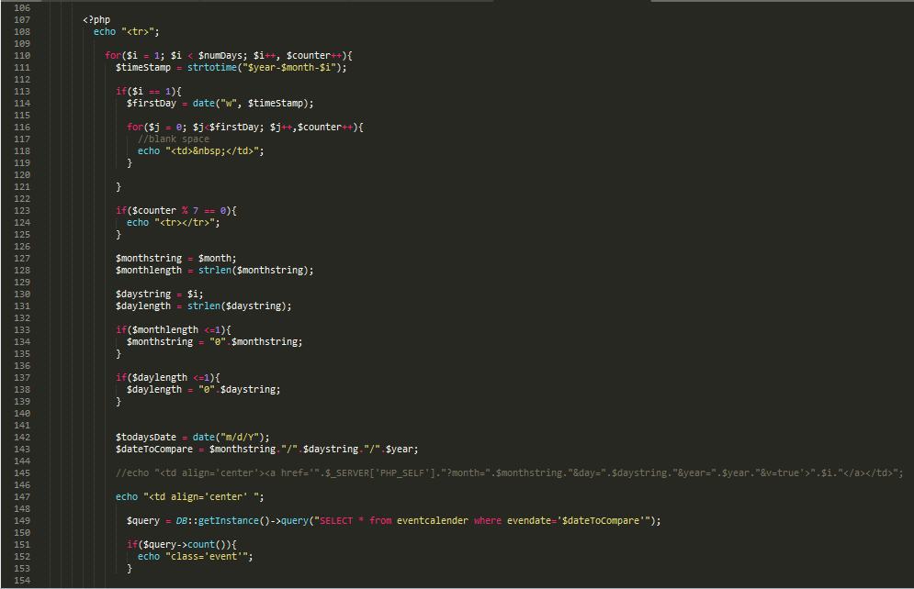

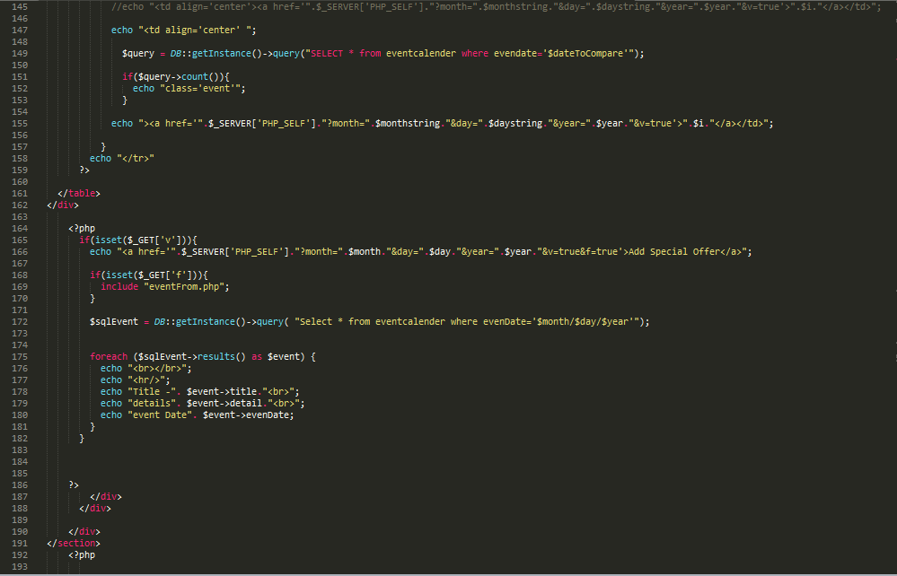

# Task 5:

In here I discuss about modify of booking cabin but thy cannot delate.

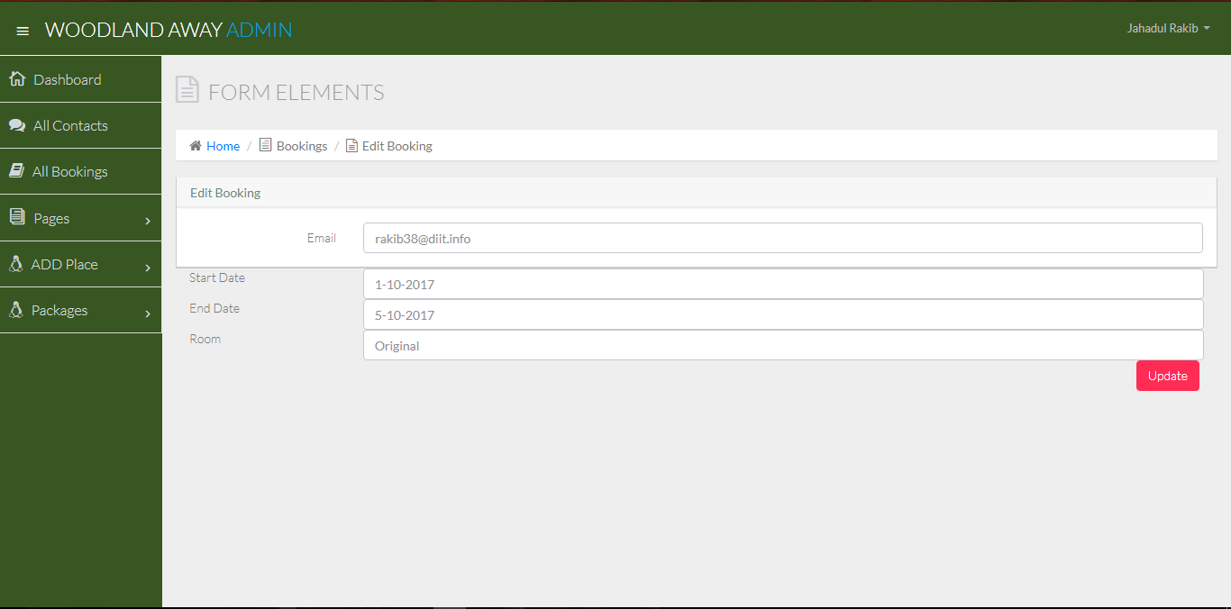

All Code of Update Bookings

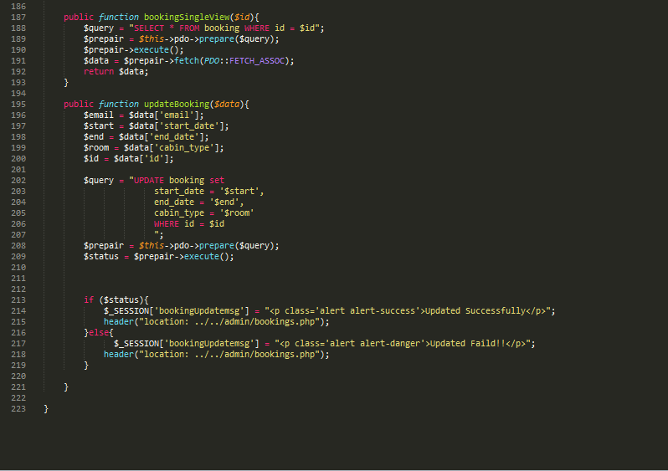

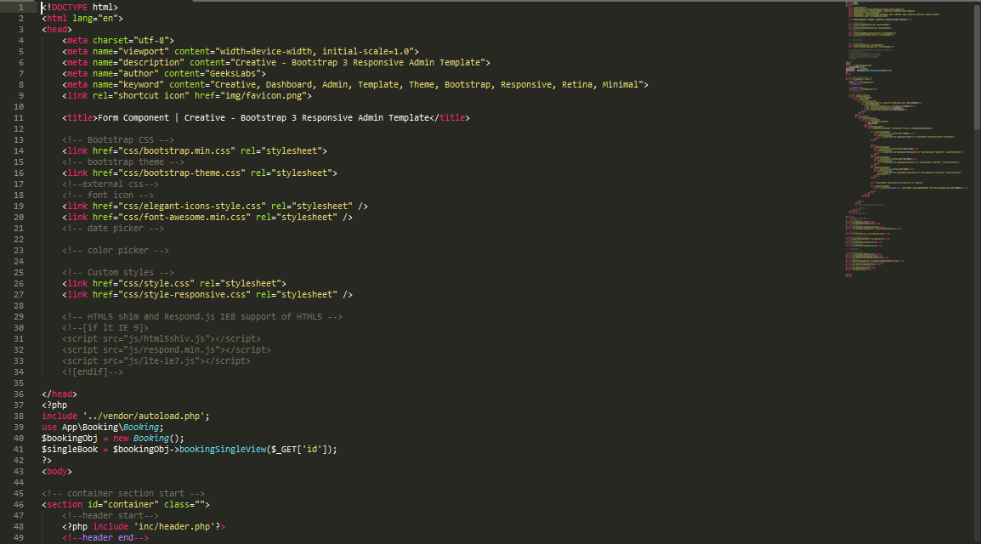

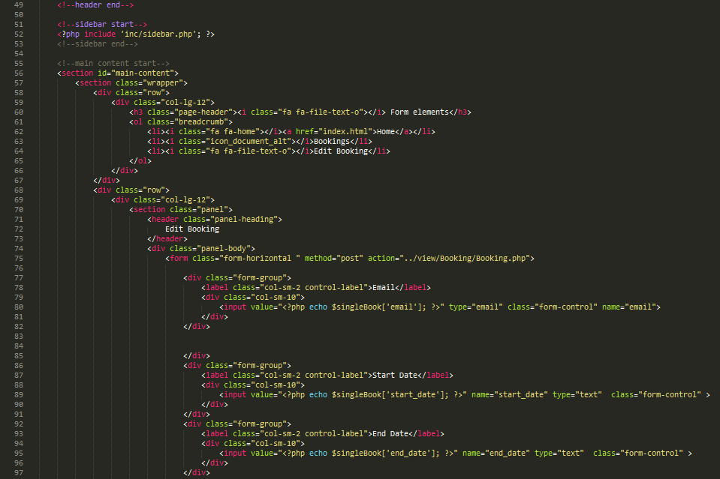

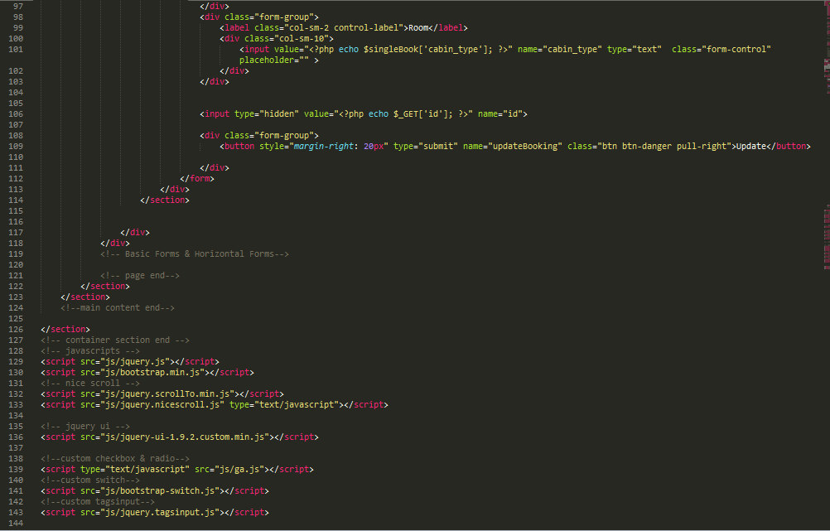

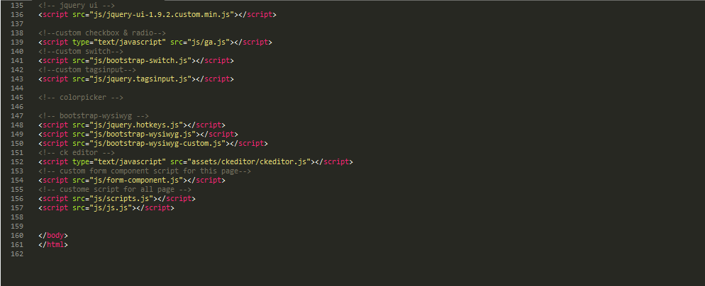

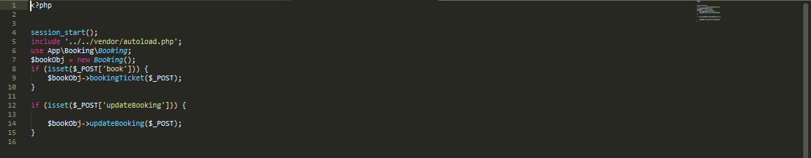

# Task 6:

In here I will describe about booking system and mail confirmation.

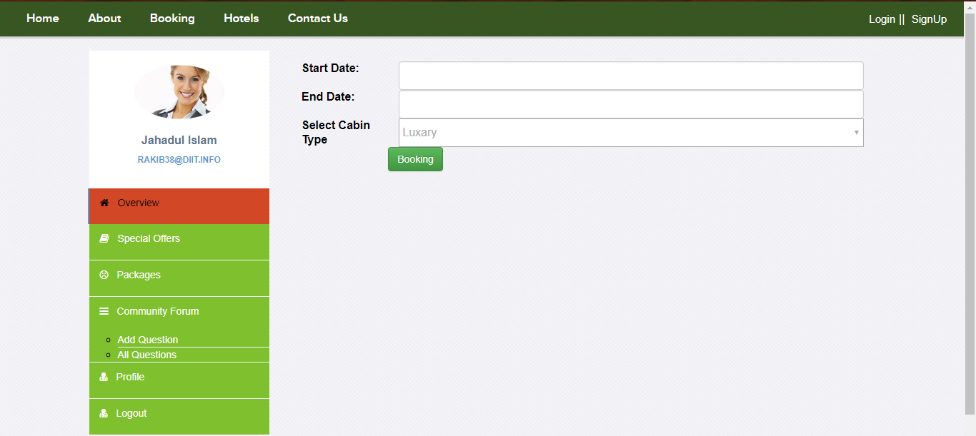

Booking and Mail Successful message.

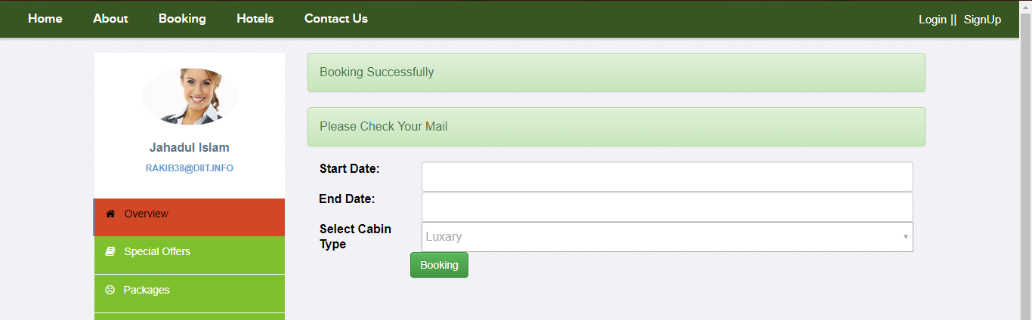

Booking Code:

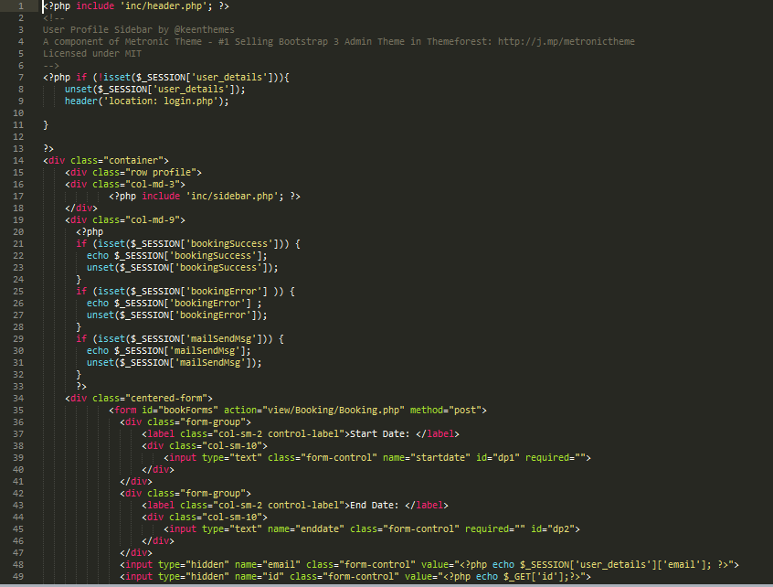

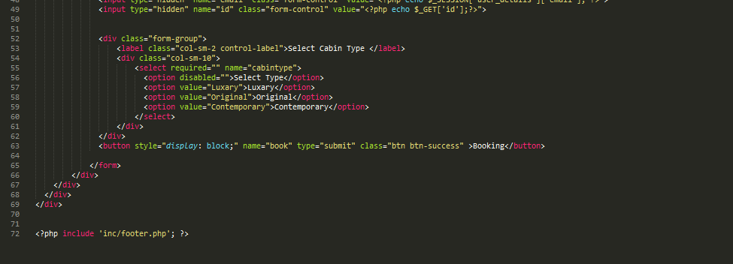

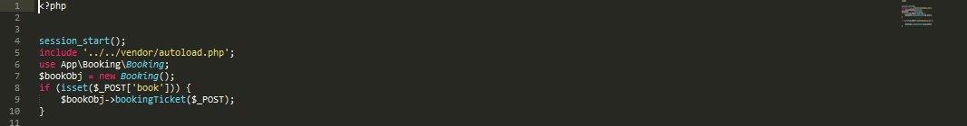

Mail sending Code:

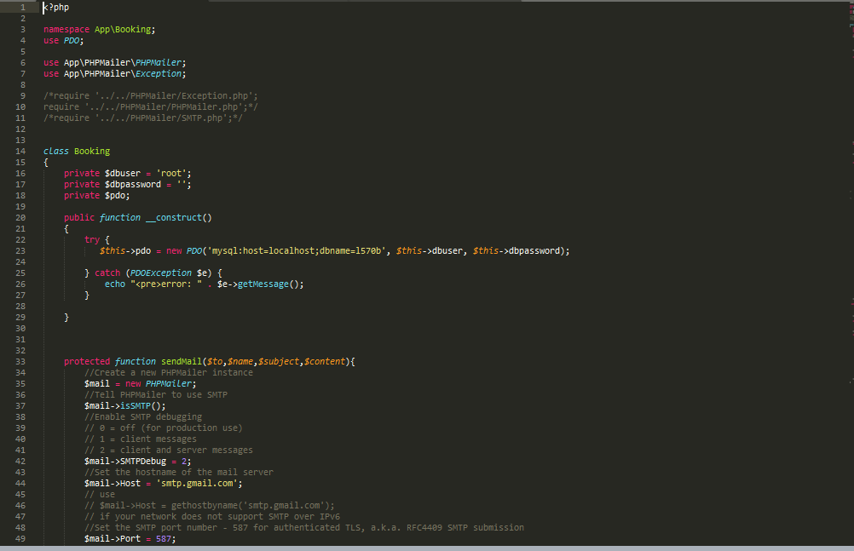

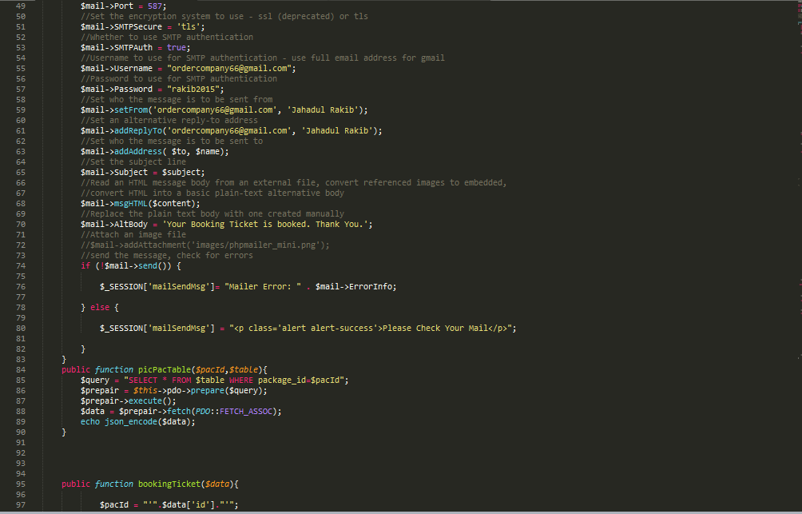

Booking Function for check quantity of cabin and define and store the cabin type:

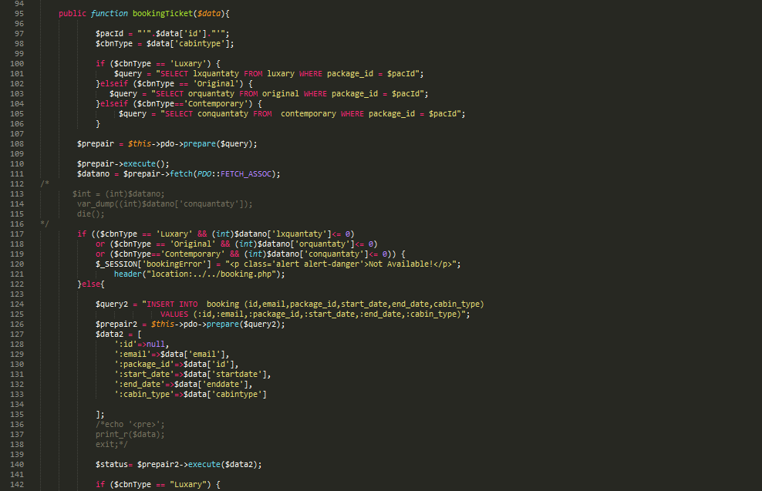

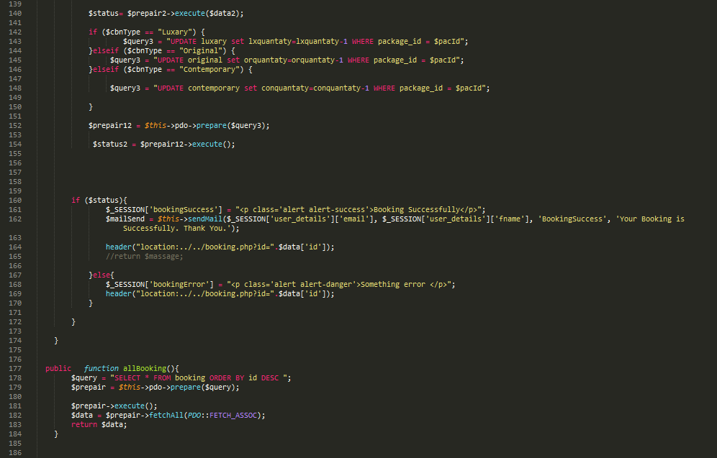

All Booking check and get package ID last booking to send another relational table

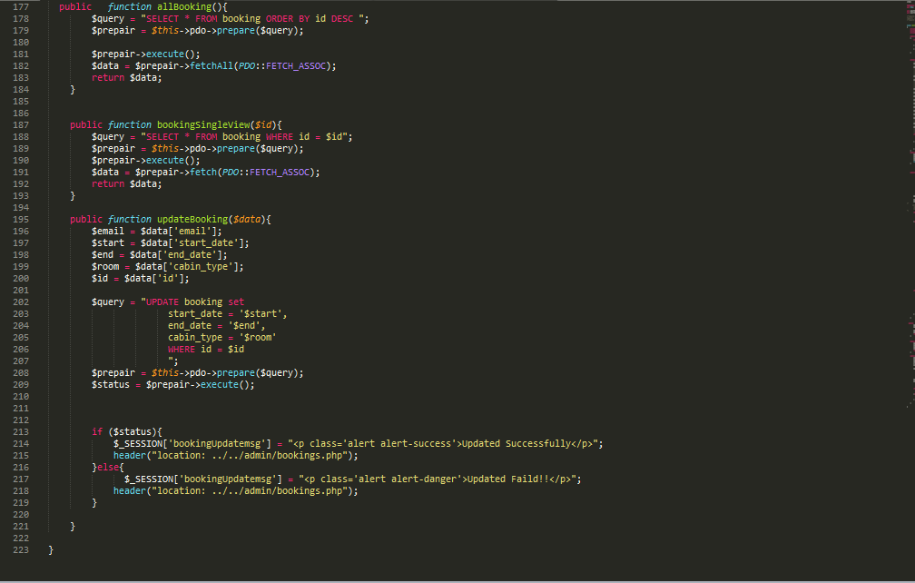

# Task 7:

Online community forum for Woodlands Away customers. Here I describe the process of community forum. A user can view Community forum side bar after login. No unauthenticated person cannot access the community forum.

### View:

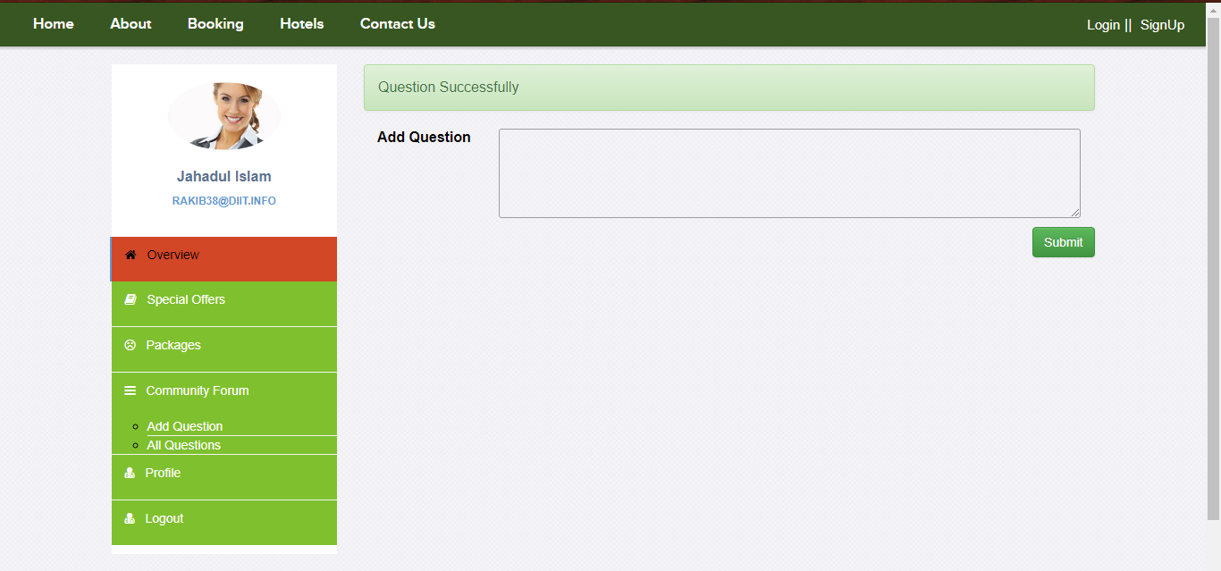

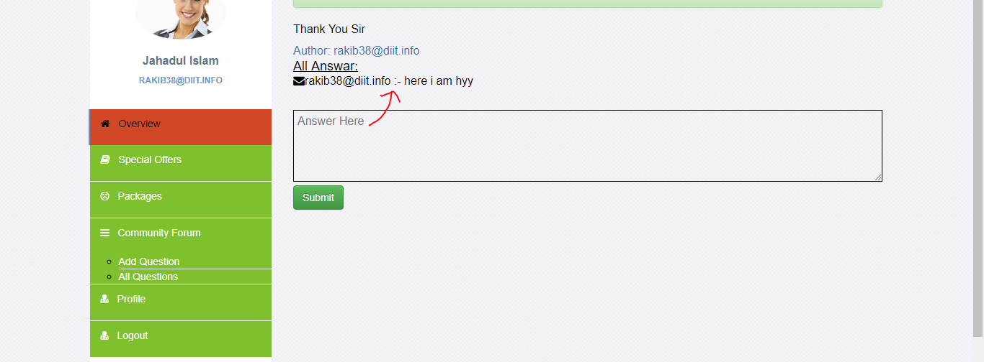

Design Page & connected with session:

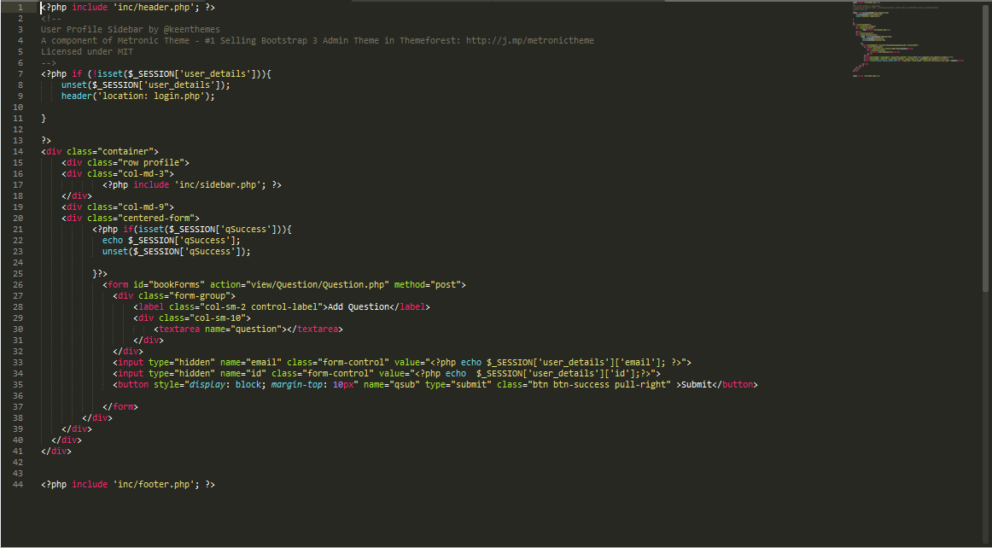

### Question & Ans:

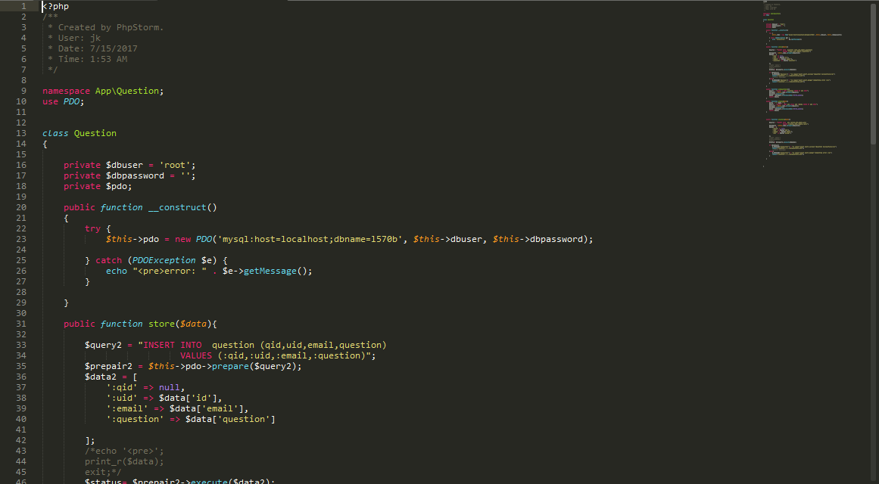

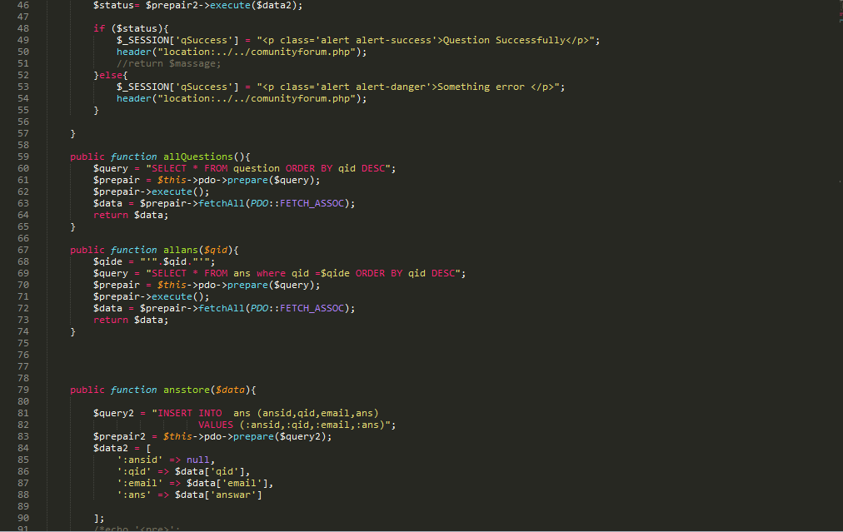

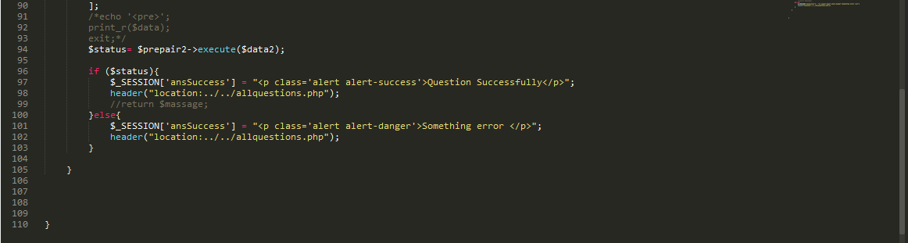

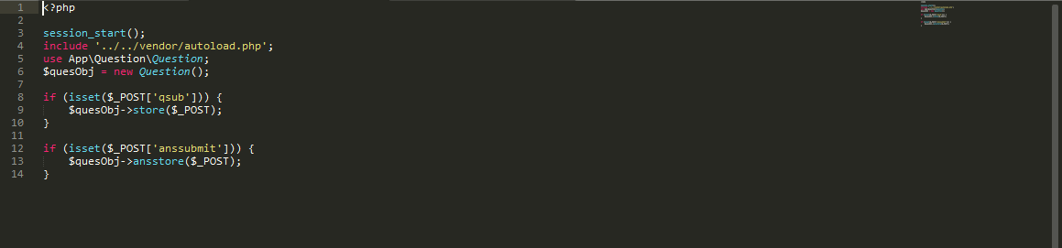

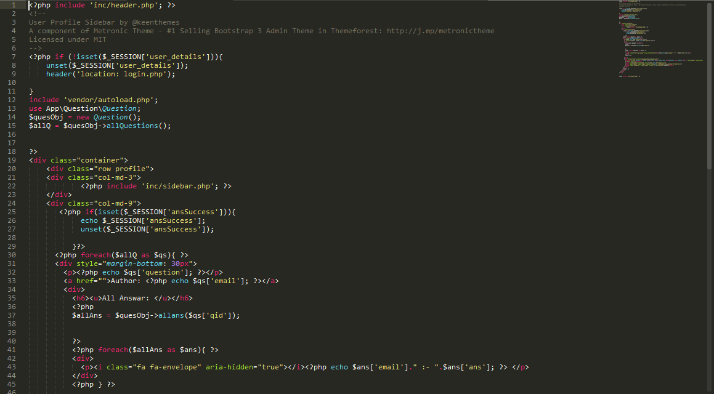

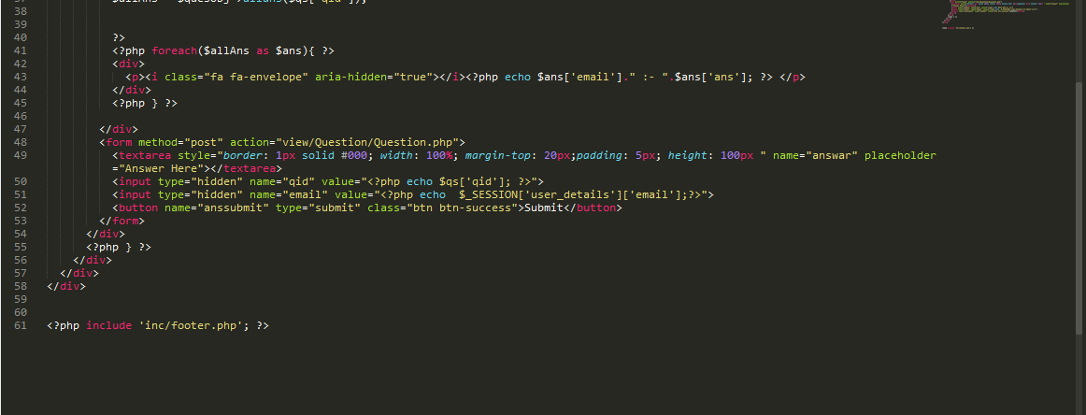

## Dashboard:

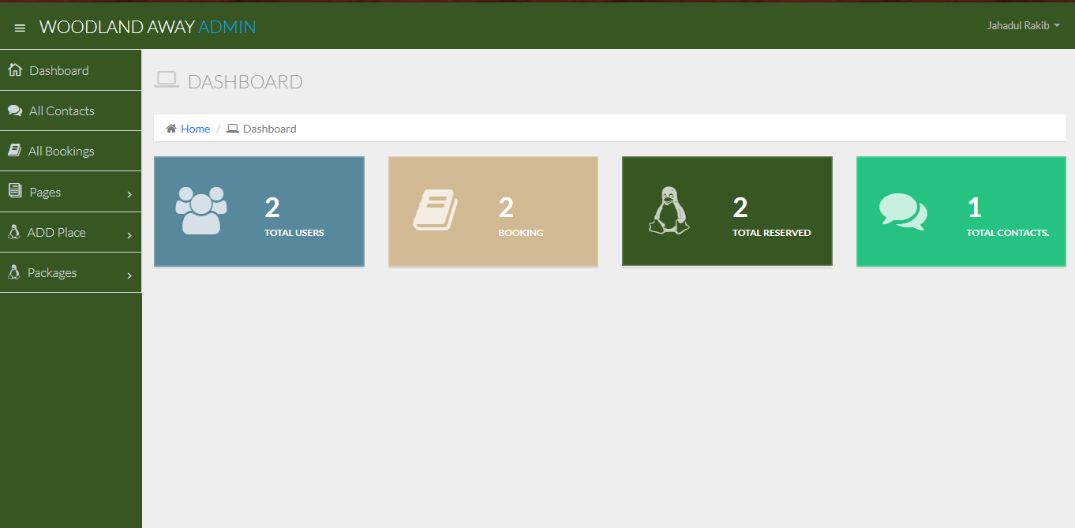

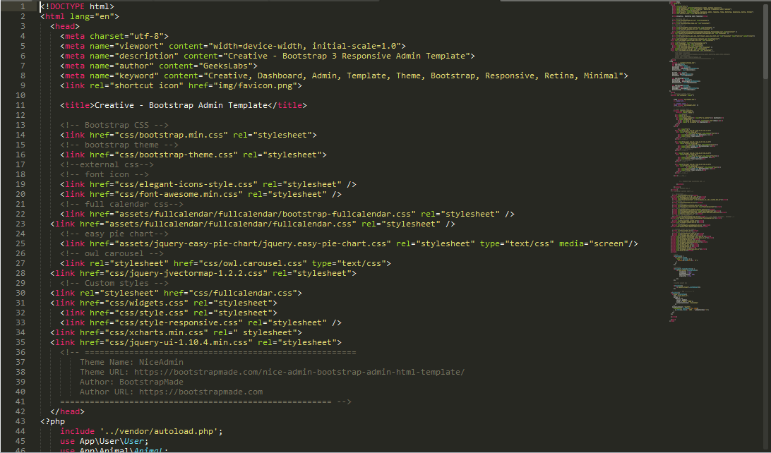

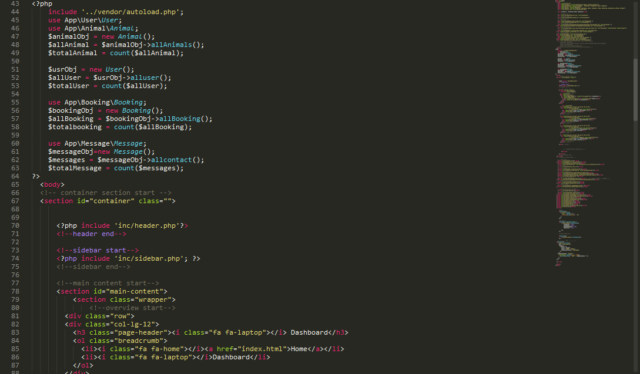

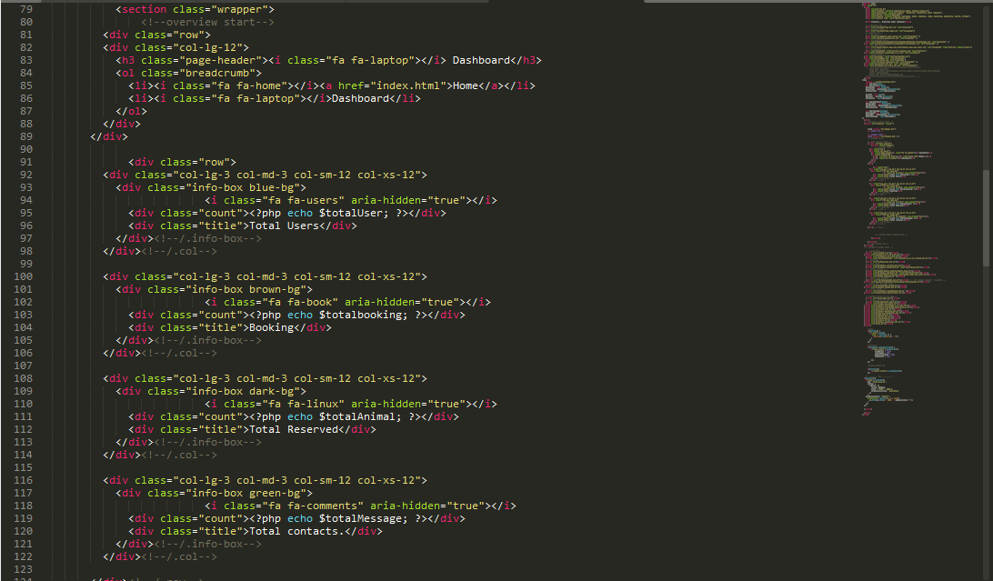

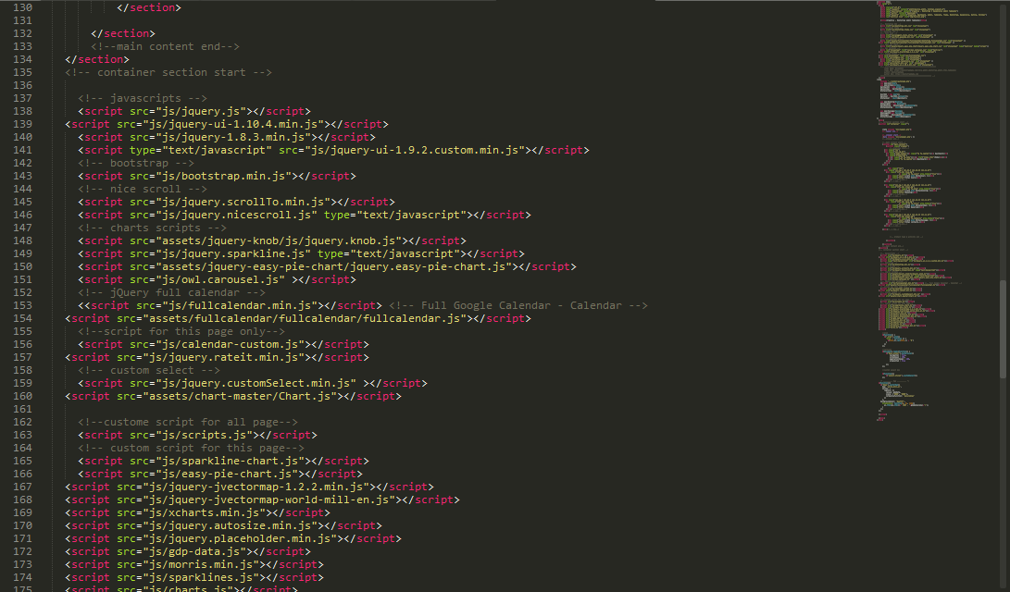

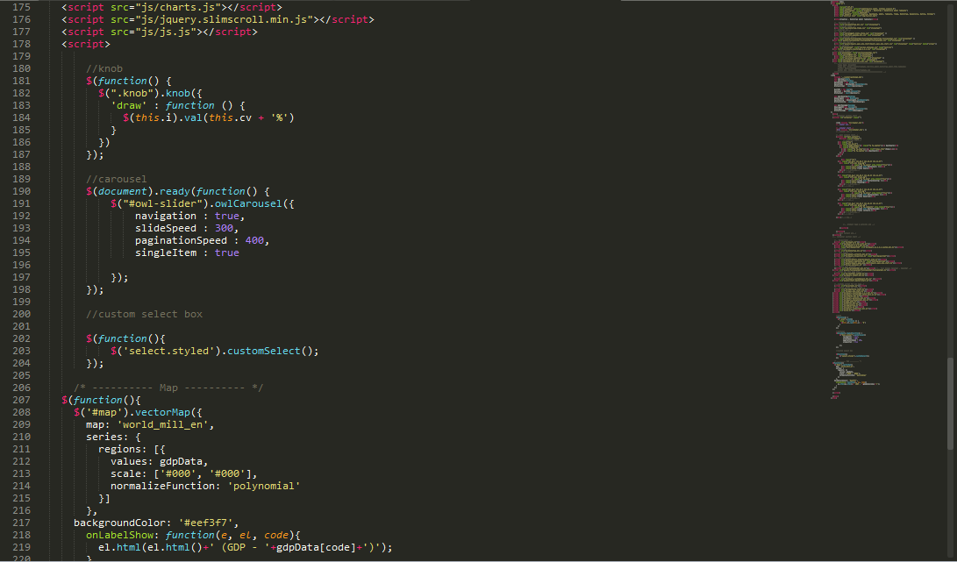

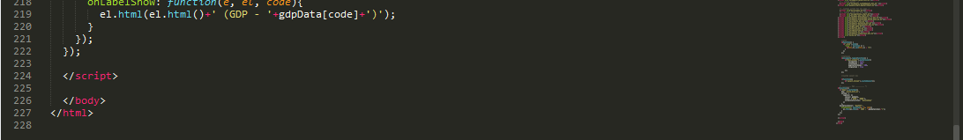

# Task 8:

Email newsletters is a great and modern marketing process. When a user uses his or her email to subscribe any online channel or media etc. then he got some Email from there which he or she was subscribe. Sometimes this kind of mail counted as a sperm message. But when a customer unsubscribes this link or media then no mail can be reach to you from there. It one kind of permission compare between yes or no. (webdesignerdepot, 2009)

Before subscribe no mail do no reach to client mail address. Subscribe means that you give permission to send you message from their mail. Otherwise if more mail come from one address, the mail server counts the mail as sperm. Remove them.

### News Letter:

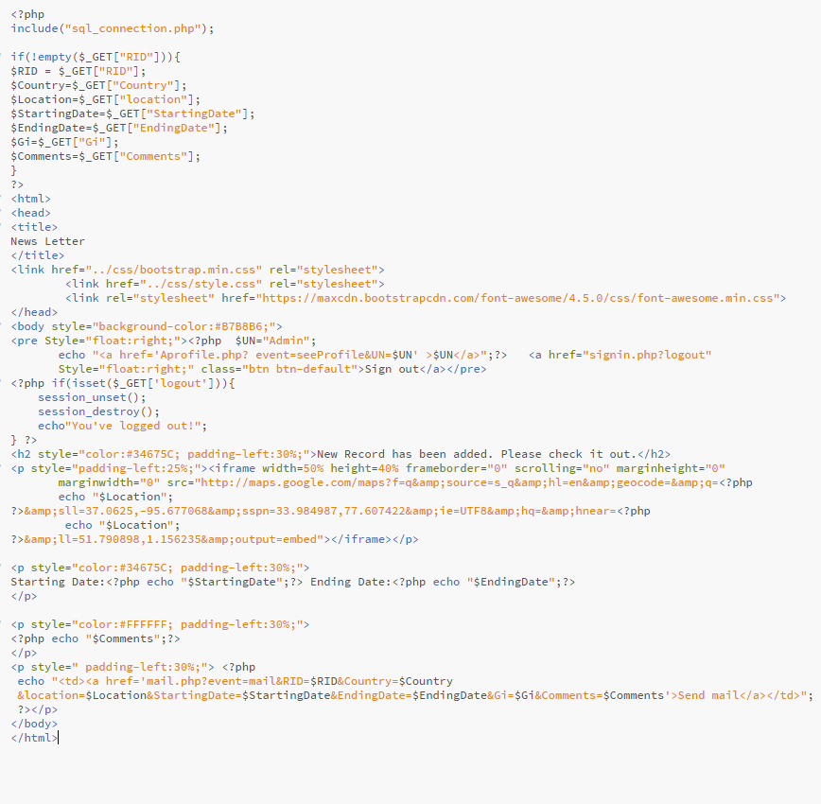

# Task 9:

## What I learnt:

When I create the assignment, I learn lot of things by facing new items. I learned how to generate database from php code. I have learned different kinds of quarry and uses may query and how they implement in real field. I also learn how to implement a website dynamically. And also learn multiple quarry and multiple database table uses. I also learn google calendar and how to use it in a real project. Selecting Date and use this calendar to represent data, how to authenticate a calendar by making use of JavaScript and also how to send mail using PHP. For this assignment first time I have used jQuery, Ajax, MVC framework and auto loader system. I have also developed Some content from admin Dynamically which is enable change Page content, Image, Field Name easily and make the site user friendly. This system development was not term of this assignment but I developed for more rebuts the system. I also help to improve my skill. Finally, in a sentence I can say that from this assignment I got an idea how work backend in a website and how to make a website dynamically. I also learn about session and how to use in different places. How to use same value multiple time and multiple classes. In that time also improve my HTML, CSS, jQuery, Database and mostly object oriented php.

## Improved or further development:

First one user interface need to be more user friendly. In future I must ensure more security in password field by using more complex hashing algorithm. And use Encryption for all kinds of data. In future development I like to use like or unlike option in comment in community forum. Such as the user question & answer which is most liked that was show first and then other. I also develop google calendar field which will be more dynamic and user friendly. In here I don’t use search opportunity for admin or customer. In further progress a fit design like search button had better be implement.

## Most difficult part:

I think the most Difficult Parts of the assignment is using of google calendar by dynamically. I never use it before. For the reason I face more difficulties for mine. I have search internet about this topic for hour. In the internet I found some solution but that was not actual which I want. But lastly, I can solve some about this problem.

# Conclusion:

At end of the assignment I can say, during I have work for complete the assignment I learn so many things. I don’t complete some parts of the assignment and I stop somewhere but it helps me to improve my skill. Almost I have got a valuable thing that confidence. It improves my confidence level. The journey was not easy for me but enjoy it.

# References

w3schools, n.d. *www.w3schools.com.* [Online]   
Available at: https://www.w3schools.com/jquery/default.asp  
[Accessed 16 10 2017].

webdesignerdepot, 2009. *www.webdesignerdepot.com.* [Online]   
Available at: https://www.webdesignerdepot.com/2009/11/a-guide-to-creating-email-newsletters/  
[Accessed 16 10 2017].